Evaluating the performance of different machine learning algorithms in predicting the outcome of Formula One races, and identifying which models are most effective.

Paul O’Mahony

Thesis submitted in partial fulfilment of the requirements for the degree of Masters of Science in Data Analytics at CCT College Dublin

## Declaration

I hereby certify that this material submitted to CCT College Dublin for the award of Master of Science in Data Analytics is entirely my own work, except where otherwise stated, and to the extent that such work has been cited and clearly acknowledged by references. Furthermore, this work has not been submitted for any other degree.

Signed: Paul O’Mahony

Student Number: sba22425

Date: 22/09/2023

## Acknowledgements

I have received a great deal of support and assistance in reaching this stage of academic research. Firstly, I would like to thank my primary school of Bunscoil Bothar Na Naomh in Lismore for providing the foundations for learning in my adolescence. This development continued to my secondary education in Blackwater Community School, before graduating with a Bachelor’s of Science degree in the National University of Galway, where my knowledge and skills for a professional environment were elevated to a new level.

I would like to extend this gratitude to the College of Computing Technology who have made this thesis possible through hard work and invaluable expertise. This research could not have been undertaken without the belief and inspiration of our lecturers, supervisors and librarians.

Lastly, I am deeply indebted to my parents and siblings for their love and unwavering support throughout all stages of my learning journey. Your belief in me has ensured that my personal growth and motivation remained high during this process and for that, I will always be grateful.

## 

## 

## 

## 

## 

## 

## 

## 

## 

## Abstract

Formula One racing is a fast clock speed industry which pitches the best motorsport teams against one another to produce their best possible product, the grand prix car. The teams must adapt and innovate each season based on factors such as new technology, human resources and regulation changes to remain competitive each season.

The goal is to design a prediction and decision support system for potential use in a professional environment. These challenges were initially addressed with the help of expert knowledge of the domain

By using a combination of the fundamental principles of data processing, statistical analysis and machine learning algorithms, the model focuses on data such as results, drivers, circuits and weather to predict the winner of the races presented.

## Table of figures

**Table of contents**

**Declaration 2**

**Acknowledgements 3**

**Abstract 4**

**Table of figures 5**

**Introduction 7**

Background and Context 7

Problem Statement 7

Research Questions 8

Research Objectives 8

**Theoretical Research 9**

Literature Review 9

**Experimental Research 16**

Research Methodology 16

Domain Understanding 18

Data Understanding 18

Data Dictionary 18

Data Exploration 19

Missing Values 26

Data Preparation & Feature Extraction 27

Modelling 31

Linear regression 31

Random Forest regression 31

XGBoosting 32

Decision Tree regression 32

K-Nearest Neighbor 32

Long Short Term Memory 32

Model Evaluation 33

Mean Squared Error 34

Root Mean Squared Error 36

Random Forest regression 42

XGBoost 44

K-Nearest Neighbors 46

Decision Tree Regression 48

Long Short Term Memory 48

Model Deployment 49

Further Research 49

**References 50**

## 

## Introduction

### *Background and Context*

Formula One is considered the pinnacle of motorsport in Europe, where twenty high-speed cars compete against one another on a given circuit. These races have been governed by the FIA (Fédération Internationale de l'Automobile) since its inception in 1950, when the first Formula One race was held. Since then, Formula One has become a multibillion-dollar industry. The ten Formula One teams travel from one side of the globe to another on a weekly basis, transporting their entire set-up which consists from staff to equipment through various modes of transport. These demands on all involved have risen year on year due to the worldwide fanbase for the sport, with the Netflix series ‘Drive to Survive’ being an obvious contributor to the increased exposure.

The series helped to highlight the importance each team places on utilising speed and minimising their lap-time. The best lap-time is invariably achieved by following the optimal racing line. This consists of the shortest path around a racetrack and the points within the track configuration that enable a driver to achieve the car’s highest possible speeds. Within the domain of formula one racing, there are different scenarios and variables which can dictate the outcome of a race and fastest lap-time. Weather conditions will always influence a team’s strategy for a race and how they approach tyre changes during the race.

The Formula One rules require a driver to use two different types of tyres and this rule is waived if there is rain or inclement weather conditions at any stage of the race, where wet or intermediate tyres are needed. Tyre compounds consist of soft, medium and hard. A softer compound tyre usually results in faster lap times but degrades faster than a harder tyre compound. Pit stops are primarily used to replace the tyres on the car due to tire degradation (worn-out tyres) or weather changes, repair broken parts under the assumption that the car does not have to be retired, or to complete a time penalty which may have been issued by the race director. For safety reasons, there is a restricted speed limit when driving through the pit lane which results in a further time loss compared to driving past the lane on a race track.

Other key variables in the outcome of a driver's finishing position in a race include the limit of the car and engine performance, driver’s experience and skill, along with the driver and team’s strategy throughout a race and the decision making process that determines this. The sport has certainly become more data driven in this respect as the more reliable these data predictions are, the better the strategies become. Reliable data is an important factor in strategic decision making and can provide the underlying basis for deploying machine learning techniques to gain a competitive edge for a given team.

### *Problem Statement*

When looking to address the problem of determining which algorithms are most reliable and accurate in predicting the race outcome, the relevant factors must be explored through the historical data available. These include previous driver and team performances at a given track, weather conditions per race, number of pit stops taken and the length of time per stop, to name but a few.

The research problem is, therefore, defined as the lack of clarity around which machine learning algorithms provide the greatest accuracy in predicting race outcomes. These techniques are used by teams to drive their race strategies and gain a competitive edge where possible, but the exact algorithms used or structure of these models have not been divulged to the public.

### *Research Questions*

1. What variables have the most significant impact on the accuracy of the predictive model for Formula One races?
2. What are the potential benefits of using machine learning algorithms for predicting the outcome of Formula One races, beyond improving the accuracy of actual outcome predictions?
3. Could machine learning algorithms be used to help level the playing field between teams with different budgets or resources?
4. Could the use of machine learning algorithms introduce new ethical or privacy concerns in Formula One racing, and if so, how could they be addressed to mitigate any potential consequences?

### *Research Objectives*

Research objectives define the most important tasks completed throughout the research and are motivated by a desire to understand how machine learning algorithms can interpret and predict formula one outcomes based on the historical data fed to the models.

1. Identify the key features that can influence the result of a Formula One race and the weight or importance of each.
2. Transform the Formula One data gathered by applying Machine Learning techniques with respect to these key features to predict the outcome of a race based on historical data.
3. Critique the outcomes achieved through these techniques and analyze their effectiveness in being deployed in a professional environment for a competitive edge.

## Theoretical Research

### *Literature Review*

Formula One is a sport of fine margins where driver and car performance is differentiated to a tenth of a second. A competitive edge for any of these teams over their rivals can pave the way to success throughout the season and improve the finishing position of their cars per race. The introduction of data analytics and more specifically, advanced machine learning algorithms has enabled Formula One teams to process real time data and improve their strategic decision making on a race [1]. The prominence of data analytics in the sport poses the question to whether a race outcome can be accurately predicted and this exploration can be generally divided into three different spaces: psychological, mathematical and machine learning techniques.

When looking at the key concepts and theories around the prediction of sport results, Artificial Neural Networks (ANNs) seem to be the most common unsupervised approach to sport result predictions [2]. An ANN uses interconnected components to translate several inputs into the desired learning output and its power comes from the non-linearity of the hidden neurons, where the weight adjustment here contributes to the final model decision [3] [4]. A study by Bunker and Thabtah [5] [6] examined the application of unlabelled data for sports winner prediction. The ANNs attained a greater accuracy score of 71% once the most suitable metrics for the data had been chosen. [7]

Passfield [8] delves into the emergence of sport analytics and the mix of specialties involved such as mathematics, human physiology and big data. The study provides positive sentiment towards the ability sport science has in reforming knowledge based on player behaviour and sports in general.

The study of Neural Networks in the sport of greyhound racing conducted by Johansson and Sönströd [9] found that the methods performed better at the harder formats and strived for greater value rather than reverting to the simple choice of the favourite in a greyhound race, even when the odds were not supplied to the model for this study. The study demonstrated the complexity at which the Neural Networks perform and their desire to strive for the best possible outcomes when provided with the necessary data to do so.

Another study on greyhound racing predictions is that of Chen, Rinde, Sutahjo, Sommer [10] where two machine learning approaches were deployed, decision-tree and artificial neural networks. This was complemented with three human track experts to compare the algorithm's accuracy against the experts. With the assistance of the experts, the performance variables were reduced from 50 to 10. The results showed that both the decision tree and neural network methods outperformed the human experts for expected profit.

Davoodi, Khateymoori [11] also applied artificial neural networks to predict horse racing results. Data from 100 races at the Aqueduct racetrack in New York from 2010 were selected, where one neural network was used for each horse in a race. The eight features consisted of the horses weight, class of race, horse trainer, jockey, race distance, number of horses in the race, track conditions and weather [12]. These eight features made up the input layer, two hidden layers, and the output layer defined as the horse's finishing time. With over 400 epochs in place, an accuracy of 77% was achieved.

When looking at studies based on athletics and how this data is interpreted based on feature selection, Ofoghi, Zeleznikow, MacMahon, Rehula, and Dwyer [13] published a study regarding the prediction of triathlon results. It emphasised the importance of the data processing phase for this research and the relevant factors that can influence the winner’s performance. When importing the data, the researchers learnt that converting the time variable from HH:MM:SS format to raw seconds helped to emphasize the dominant performance of the leader and other participants against the field.

In the paper of Przednowek, Iskra and Przednowek [14], a similar study is conducted on the athletics discipline and specifically, a 400-metres hurdle race. The data of 21 athletes from the Polish National Team is examined through nonlinear methods [15] and the artificial neural network returns a prediction error of 0.72 seconds, with common predictors for the results also specified for these results such as age, speed endurance and other impacting factors.

Edelmann-Nusser, J.; Hohmann, A.; Henneberg, B. [16] explored the performance of female swimmers in the finals of the 2000 Olympic Games in Sydney by also using nonlinear neural networks (multi-layer perceptrons) through training data from 19 competitions prior to the event, which they found was insufficient in accurately training such networks. [17] The neural models were validated using the ‘leave-one-out’ method, resulting in effective risk-aversion and an error prediction of 0.05s. [18] [19]

Abut, Akay, Daneshvar, Hei [20] undertook the challenge of predicting the racing time accuracy of cross-country skiers. The study concluded that the 3 artificial neural networks used; Multilayer Feed-Forward Artificial Neural Network (MFANN) [21], General Regression Neural Network (GRNN) and Radial Basis Function Neural Network (RBFNN) [22], are fit for making predictions for skiing events due to acceptable error rates from these models.

Another study conducted by Sankaranarayanan, Sattar, Lakshmanan [23] analysed the prediction of a cricket game outcome through regression models while the game was in progress. The application of Ridge regression and attribute bagging algorithms helped to provide a prediction accuracy of 70%, higher than any reported studies in cricket mining. Factors that could influence the game outcome such as the toss, batsmen historical data and other parameters through the use of linear regression and nearest neighbour clustering algorithms [24].

Bailey, Clarke [25] also explored machine learning methods to predict the outcome of a cricket match between two teams and their respective features. The feature selection within this study is relatively small and does not offer a direct comparison between this study where ten individual teams will be examined and the feature selection is expected to be higher. [26]

Various studies are available within the sphere of European football and the machine learning methods applied to this data. Tax and Joustra [27] researched a result prediction system for the Dutch Eredivisie league by testing different combinations of dimensionality reduction techniques and classification algorithms. Joseph, Fenton, Neil [28] published a study based solely on the prediction of game results for the Tottenham Hotspur team during the years of 1995-1997 using a Bayesian network which was constructed by a domain expert and found that the domain knowledge [29] of this expert helped the network to outperform machine learning models that are constructed based on data analysis.

Goddard [30] approached the football prediction challenge from a different angle to most by comparing the modelling of goals scored versus the modelling of win-draw-lose results, rather than just using the previous match results. He concluded that a hybrid model achieved the best possible prediction based on the 25 years worth of data collated from English football matches. The features chosen here include the importance of certain games and the geographical distance between the two opponents.

Hucaljuk [31] used data from the Champions League tournament to set a target accuracy of 60% from their Naive Bayes, K-nearest neighbour and Random Forest techniques. The results outperformed this target accuracy by almost 9% but Hucaljuk outlines the possibility of improving feature selection to include individual player data in the quest to achieve greater results in future works. This would obviously increase the workload significantly and require more resources to achieve this but has greater implications for overall accuracy return from the algorithms.

Broich [32] used data from 153 games within the German Bundesliga to highlight the importance of efficiency when looking at the significance parameters for a match outcome [33]. The number of shots and passes taken by a team, along with the number of touches in the game were deemed important variables also. The study also provided insight that the expected impact of the distance covered by a team did not significantly influence the winning attribute.

Kampakis published two studies which looked at data in relation to the English Premier League. The first study [34] used Twitter posts to predict the outcome of these Premier League matches and proved that the social media platform has useful information for this objective. The author reported that the Twitter-based model performed better than historical data and statistics but increased its accuracy further when mixed with other prediction models.

The second study [35] involved collaborating with two Premier League clubs to predict player injuries in football. This included using machine learning algorithms to predict the recovery time needed for a specific injury, where correlation-based feature selection was used to improve the performance and reliability of this model. The prediction of a player getting an injury was studied through the relationship between the hours of training and matches played by the player with the number of injuries recorded. With the consent of the club, the GPS player data was analysed to see if overtraining or fatigue were contributors to an injury and also to predict if a player is threatened by injury based on the collated data.

Both Rue [36] and Pollard [37] deployed the iterative simulation technique Markov Chain Monte Carlo [38] to predict the outcome of English football matches. A dynamic structure was used in their models to facilitate the updating of parameters once more game results were fed into the existing dataset.

Ulmer, Fernandez, Peterson [39] discussed the use of machine learning algorithms within Premier League data to predict match outcomes based on the 2012-2014 seasons. The collated results confirmed that the outcome of a draw within these results were hard to predict and these predictions were detrimental to the accuracy of the prediction model. The algorithms used included stochastic gradient descent [40], linear support vector machines and random forest [41].

McCabe, Trevathan [42] took a broader approach to their sports prediction results through four sports; Football, Australian Rules Football, Rugby Union and Rugby League. The artificial neural network had 20 input nodes, 10 nodes in the hidden layer and 1 output node. The feature selection consisted of features that were common to all sports included, with any specific to just the one sport not included [43]. The algorithm returned an average performance of 67.5% in this study.

Haghighat, Rastegari, Nourafza [44] conducted a similar study into the data mining techniques for predictions of sport results. They discuss various classification methods such as Artificial Neural Networks, Support Vector Machines, Bayesian Method, Decision Trees, Fuzzy System and Logistic Regression [45] [46] [47]. The study outlined the advantages and disadvantages of each method used and could not provide an overall best method due to the different sports tested in the paper.

The use of American sport data has also been included in this review due to its wide availability and both Purucker [48] and Khan [49] used statistical data from the National Football League in America to deploy Artificial Neural Networks for the prediction of NFL games, to which the outcomes proved both equal and better than the experts respectively through a combination of different classification algorithms.

At college level, Leung and Joseph [50] challenge the use of traditional statistical comparison between the two competing teams of that given year, as players' skillsets are more interchangeable due to the turnover of players at this level. They adopt a prediction method based on the historical results of American college football teams overall. Another college football study by Delen, Cogdell, Kasap [51] found that regression-based predictions were better than classification-based ones by roughly 11% with the data provided.

Talukder [52] explored the possibility of injury within the National Basketball Association (NBA) players and used machine learning techniques to create a model for injury prevention during a game. The model achieved high accuracy figures for short-term injury prediction and ranked injuries based on the economical expense caused and the impact a player would have on the team’s performance if he was not strategically rested instead.

Kuehn [53] devised a framework for evaluating NBA players skillset and how these compliment the overall performance of the team. A probabilistic model for possessions, which considered factors such as the opponents lineups and in-play events revealed that players are mostly considered on their individual statistics in the sport and does not place enough emphasis on their complementary contributions to the overall team performance.

Wiseman [54] used various regression algorithms to predict the winning golf score on a PGA event based on the scores after round 1. Through linear regression, neural network, Bayesian linear regression and decision tree regression, the prediction of the winning score was accurate 67% of the time [55]. Feature selection included the round 1 leading score, round 1 average score, course par, major event and course yardage. The results were validated on 2016 scores based from the models training of data from 2004 to 2015.

Although the study of Formula one is limited, there is motorsports literature available through the examination of American NASCAR racing to support this. Pfitzner & Rishel [56] delved into the possibility of reliable predictors existing in the outcome of a race through correlation analysis and found that certain factors such as qualifying speed, pole position and driver experience. One of the main conclusions from this study was the effect of team membership i.e., number of team members being two or three, however, this will be irrelevant in this study due to the number of drivers per team being fixed to two. A similar study performed by Allender [57] found a correlation between the starting position of each driver and their experience to their finishing position in a race through the regression model used. This study questions the element of flair over experience which will be an interesting point of exploration for this research.

Depken, Mackay [58] offer an insight into the structure of a team motorsport like Formula One when they analysed the NASCAR Sprint Cup Series from 2005 to 2008, using multiple regression models. The conclusion from this was multi-car teams perform better in overall team finishing positions and cooperation.

The research papers so far have focused on data generated from the players within their respective sports. In Formula One, however, the car itself has more than 250 sensors attached when competing in both qualifying and championship races. In a recent video created by the Mercedes-AMG Petronas team on their YouTube channel [59], they discuss their typical data generation output over a race weekend. Up to 1TB (terabyte) of data is recorded per car and they estimate 30MB of live data is generated per lap. The sensors also vary in function to comply with regulatory requirements for a tyre pressure monitoring system, along with providing real-time data on temperature, speed, tyre degradation and pressure.

An article published by Alex Woodie [60] also features the head of IT with the Mercedes team who highlights the volume of data generated through these sensors over a given season. With over 10TB of data being collected during this time, the data is stored using cloud storage array solutions and poses an issue with how many eyes can sift through this data. Instead, the team has adopted an approach to look at the anomalies within this data to gain greater insight and drive their decision making throughout the season.

To continue the focus on the collective contribution, Bell, Smith, Sabel and Jones [61] delve into the efforts of both driver and team and reach the conclusion that the team effect greatly outweighs the drivers effect (86% contribution) and quantifies the increase in driver changes, where as team effects have a ‘legacy effect’ and are steady based on accumulated experience.

Eichenberger, Stadelmann [62] published a study on the best Formula One driver over a 57 year period, from 1950 to 2006. The authors took the view that driver performance is dependent on the capability of their car and their innate talent. Through the application of linear regression techniques, variables such as collisions, engine failures and disqualification were removed from the study. Two control variables were also introduced to provide balance and robustness, that being the team partner driver and home advantage for a driver when racing in their own country.

A comparative analysis between both Formula One and NASCAR has been conducted by Silva, Silva [63] to outline both the similarities and differences between both disciplines. Qualifying and race data from the 2009 season is explored to achieve this. One clear difference between the sports is the fact that NASCAR has double the number of races and drivers in a season. The similarities include the point scoring system for driver and constructor championships, as well as the qualifying laps scheduled before race day to determine each driver's starting position on the grid. Four key variables were defined to gain insight into race predictions; Qualifying, Practice, Points and Results. The research confirmed that the Qualifying variable, which held the results of each driver’s qualification time, had the greatest significance in predicting Formula One results. To compare this with NASCAR, a combination of the Practice and Result data formed the strongest prediction for NASCAR. One key difference to note here is the rules around rain occurring during a NASCAR race, where the race event is cancelled.

Graves, Reese, Fitzgerald [64] used a Bayesian hierarchical framework to analyze the NASCAR racing results. They assess the driver’s abilities and predict their future standings based on the rate at which their skills have improved throughout a given season. The study also provides insight into the existence of track specialists - some drivers perform much better on certain tracks than others.

When looking at factors that can influence the outcome of a Formula One race, the study performed by Biemann, Liu, Zeng and Huang [65] used reinforcement learning to identify recurrent patterns and LSTM (long short-term memory) architecture to gain achievements in the model outcome. This study offered an alternative approach to addressing the weather calculations for this study which was not approached in the other literature.

Choo, C.L.W. [66] published a research paper which compared the insights gained from the work of Tulabandhula, Rudin [67] which focused on pit stop strategy and tyre changes based on a given track within the season. The suggestion of adding more features surrounding pit stops and pit crew performance for further insight was a novel suggestion here.

Aversa, Cabantous, Haefliger [68] collated data from the infamous final race of the 2010 Formula One season, where Ferrari’s decision support system provided incorrect conclusions and in turn, influenced their race strategy to deny Fernando Alonso a world title as expected. The Ferrari team chose to align their pit stop strategy with their rivals at the time, Red Bull, and pitted the car shortly after their competitor. This non-data driven strategy forced Alonso to re-join the circuit in the midst of a condensed field and hinder his ability to progress past other cars and ultimately, lose the expected championship title.

Looking at the relationship between Formula One and technology and referencing the research question of the potential benefits machine learning algorithms can have on the decision making in the sport, Jenkins [69] investigates the relationship between a team’s competitive advantage and their ability to adapt to changes in technological knowledge or discontinuities. The study finds that competitive advantage is achieved through a team's capability to pivot through successive technological discontinuities. The two capabilities are defined as dynamic and sustaining capabilities.

Aversa, Furnari, & Haefliger [70] link to this study when analyzing the relationship between the business model and racing performance. The business models in Formula One are broken down into four; Internal Knowledge Transfer, External Knowledge Transfer, Formula One Supply and Talent. The four models evaluate the collaboration between Formula One teams and manufacturers, the sales of technology externally to other industries, the transferability between Formula One teams regarding supply and the scouting systems set for investing in both existing and future talent.

The authors focus specifically on the Red Bull and Williams racing teams and place the spotlight on their key factors such as financial, technological development and knowledge and human resources. The conclusion offers positive sentiment to the Red Bull strategy to invest in younger drivers and allocate costs to technological advancements instead.

Rosso, Rosso [71] examines the relationship between various race factors such as the weather and tyre types from the data distributed after the 2016 Monaco Grand Prix. They applied quantile regression [72] to study these factors in greater detail and the role the weather conditions had to play on the outcome of this specific race.

Sundar [73] provides a great insight into the 2005 Monaco Grand Prix.Kimi Raikkonen, a Finnish driver. was the fastest driver on Saturday’s qualifying and started the race from first place. He was competing with the title contender Fernando Alonso at the time in second place. It was on lap 23 when Minardi’s driver Christijan Albers crashed into a wall and the Safety Car was deployed. It is an unwritten rule in F1 that when the Safety Car is on track, the team strategy should always be to pit their cars. This is due to the fact that cars have to slow down once a safety car has been issued and follow this car around the track at a reduced pace, thus, reducing the impact of time in the pit. Alonso pitted immediately as it was expected, but surprisingly Raikkonen stayed on the track. This decision was made by McLaren chief strategist Neil Martin, after assessing all the data available. This decision to stay out on track was made within a minute of receiving the notification that a safety car had been deployed. Through the use of data analytics in this scenario, the team chose to take a risky decision and go against the grain of pitting the car. In the end, the decision bore fruit as Raikkonen gained a 35 second lead on Alonso and could afford to pit later in the race for the advantage of new tyres and still keep a 13 second lead when doing so. It proved an excellent decision post-race and is a prime example of data-driven decision making within sports.

Finally, a recent study conducted by Amazon Web Services [74] provided an insight into their partnership with Formula One and how the use of Machine Learning techniques and high performance computing are transforming the sport. It highlights the millions of data points being generated per second from the 300 sensors attached to a Formula One car and how the sport is becoming data-driven. The study also provides background analysis to factors which have been identified for this research such as tyre and driver performance. However, the machine learning algorithms used have not been disclosed due to their partnership with the sport and do not give guidance to the setup, training and evaluation of these models.

The literature mentioned above emphasizes the importance of feature generation and having domain knowledge in order to successfully apply this. The use of Neural Networks were applied in most of these studies and has increased in popularity for a prediction model similar to the one being proposed here. Regarding the literature available for Formula One, there are few studies published but the NASCAR motorsport studies provide some insight into the algorithms that could be used. The NASCAR studies do not provide the necessary parallels in terms of whether a driver should make a pit stop since a single tire compound is used and this would lead to a new approach being taken for the application of Formula One racing.

## Experimental Research

### *Research Methodology*

Finding the appropriate methodology for this thesis involves considering all existing methodologies and the first of these is the KDD (Knowledge Discovery in Databases) methodology. This iterative process involves extracting novel and potentially valuable information from datasets, while establishing patterns and relationships within the data. The advantage of this approach is improved decision making once the process techniques have been applied;

1. Data Cleaning
2. Data Integration
3. Data Selection
4. Data Transformation
5. Data Mining
6. Pattern Evaluation
7. Knowledge Representation/Visualization

As mentioned above, the focus within these stages of the process is discovering useful information from the data and domain expertise is a key facilitator in choosing the appropriate data and results.

The SEMMA methodology is almost identical to the KDD methodology in that every stage of KDD corresponds to a stage of SEMMA. The SEMMA development tool for data mining enables smooth data mining execution through the following steps;

1. Sample
2. Explore
3. Modify
4. Model
5. Assess

In order to get an understanding of the datasets for this research, the sampling process is initiated. Exploration of trends within the data are investigated to gain further insight and any necessary data modification is performed, resulting in variable creation. Once the data has been cleaned and variables refined, a projected model is produced through a variety of data mining techniques. From here, the model is assessed for its reliability and tested for performance efficacy.

The third methodology to consider is CRISP-DM (CRoss-Industry Standard Process for Data Mining). This methodology proposes a standardization approach to assess the potential of data mining projects and identify potential irregularities or flaws in the model in a timely fashion. The model puts forward the following steps;

1. Business Understanding
2. Data Understanding
3. Data Preparation
4. Modelling
5. Evaluation
6. Deployment

The model is mostly effective in a complex environment where a fast rate of change occurs.

The final methodology to propose is the Sports Results Prediction CRISP-DM framework of Bunker and Thabtah (2019). As expected, the methodology is based on the above CRISP-DM framework but specializes in its adaptations to a sports environment. The steps are as follows;

1. Domain Understanding
2. Data Understanding
3. Data Preparation & Feature Engineering
4. Modelling
5. Model Evaluation
6. Model Deployment

The ‘Domain Understanding’ step has been renamed to highlight the study of a sport domain instead of a specific business. ‘Data preparation & Feature Engineering’ has also been renamed in the methodology to focus on similar features in the subsets of sports data. The final three modelling steps advise splitting the data between training and test sets for model prediction accuracy purposes and retraining the models to predict new sports results in the process.

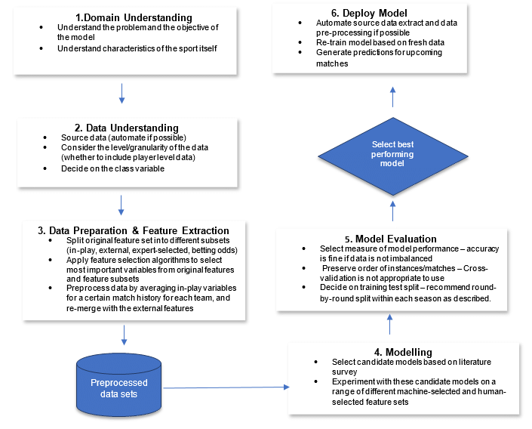

Figure 1. SRP-CRISP-DM methodology

Given the specific fit that SRP-CRISP-DM provides for sport analytics and its focus on creating race-related features within the data, this methodology was chosen for the dissertation.

### *Domain Understanding*

Bunker and Thabtah (2019) have defined the domain understanding step as “comprehending the problem, the goal of the modeling, and the specific characteristics of the sport itself”. To comprehend the problem of predicting the outcome of a race through machine learning techniques, knowledge of the sport and what factors potentially determine the race results are important.

As a keen Formula One fan for the last eight years, the release of the Netflix series ‘Formula One: Drive To Survive’ provided fans with exclusive access to the Formula One season both on and off the track. From a domain understanding point of view, the series highlights the work of all members of a constructor to gain a competitive advantage and the tactical prowess of the team principals when gaining a favourable result.

### *Data Understanding*

The first step to begin this research was to identify and validate historical data sources for Formula One racing. Ergast (<http://ergast.com/mrd>) is an open-source database where users can extract structured race data from as far back as 1950. The Ergast API allows for communication between applications to retrieve this data and a supporting database guide provides the attributes of each available table and their numerical or categorical variables within. The data consists of important data such as race circuits, race results, driver performance and team standings throughout a season.

The API did not include an important factor in race prediction which is the weather conditions on the day of a race. Not only does the weather conditions impact the overall speed of a Formula One car around a circuit, but can influence the strategy of each team for pitting their drivers at a certain time during a race and deciding which tyre compound to use also. The tyre compounds provided to each Formula One team consist of soft, medium and hard, along with wet tyres, for severe conditions.

The datasets append a URL link from Wikipedia as a unique identifier for each race. This enabled the use of the Python library BeautifulSoup to extract keywords from the race information such as wet, cloudy, warm, cold and dry. For example, if BeautifulSoup detected keywords rainy, pouring or slippery, a binary value of 1 was assigned to the weather_wet column created in the dataset. Otherwise, a value of 0 was encoded into the column for this race.

#### *Data Dictionary*

| Dataset | Dataset Content |
| --- | --- |
| Circuits | The country and city where each race took place, along with an identifier for each circuit |
| Constructor Results | The results of each team in respect of their two cars per race. |
| Constructor Standings | The standings of each Formula One team after a race |
| Constructors | Provides the team name, country of origin and unique identifier to link the team drivers to the constructor |
| Driver Standings | The standings of each driver after a Formula One race |
| Drivers | Information on each driver such as their name, nationality, date of birth |
| Lap Times | Begins with data from 1996, the dataset provides each racers lap time per round. |
| Pit Stops | The length of time taken to perform each pit stop per driver in a race. |
| Qualifying | Includes the best qualifying time from sessions 1, 2 and 3 if a driver progresses to all 3 stages. A driver can be eliminated in stages 1 and 2. |
| Races |  |
| Results | Shows the results of each race and the podium finishes. The podium finishes and race winners are important for this study. |
| Seasons | Includes all the racing seasons from 1950 and a unique URL to the Wikipedia link of each. |
| Status | Provides confirmation if the driver completed the race or experienced a race-ending issue such as an accident, collision or engine failure. |
| Weather | Created using BeautifulSoup to identify keywords in the Wikipedia page to establish wet, cloudy, warm conditions. |

#### *Data Exploration*

Exploring and visualising the data gathered can unearth insightful areas or patterns from the start. Given the vast amount of information contained in these datasets, data exploration and visualisation can quickly determine the most important areas for analysis. Variable identification and analysis, along with detecting outliers and missing values, form a strong basis of this descriptive analytics journey.

The first figure presented is the number of circuits per country since the sport’s inception in 1950. This provides an insight into the global scale of the sport and the number of race tracks allocated per country to support the industry.

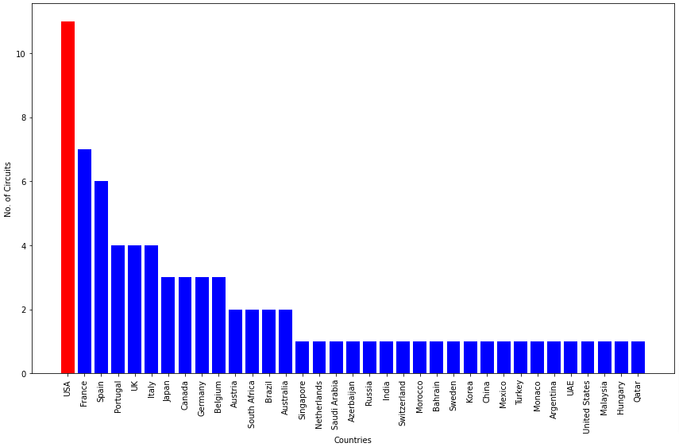

Figure 2. Number of circuits per country

The USA has hosted Formula One races in 11 different circuits and is clear of France and Spain respectively. For the 2023 season, the introduction of the Miami GP in 2022 has remained and the Las Vegas GP has been added to the calendar - a track which has not hosted a race in over 40 years.

Some of these circuits have only seen a handful of races being hosted throughout their existence and fans of the sport would be expected to name some iconic tracks such as Monaco and Monza if asked to name one circuit in the Formula One calendar. The figure below confirms that these two race tracks are the highest in the number of races hosted since the sports inception. Silverstone in the United Kingdom has ranked third highest in this figure, with the Spa race track in Belgium following in fourth.

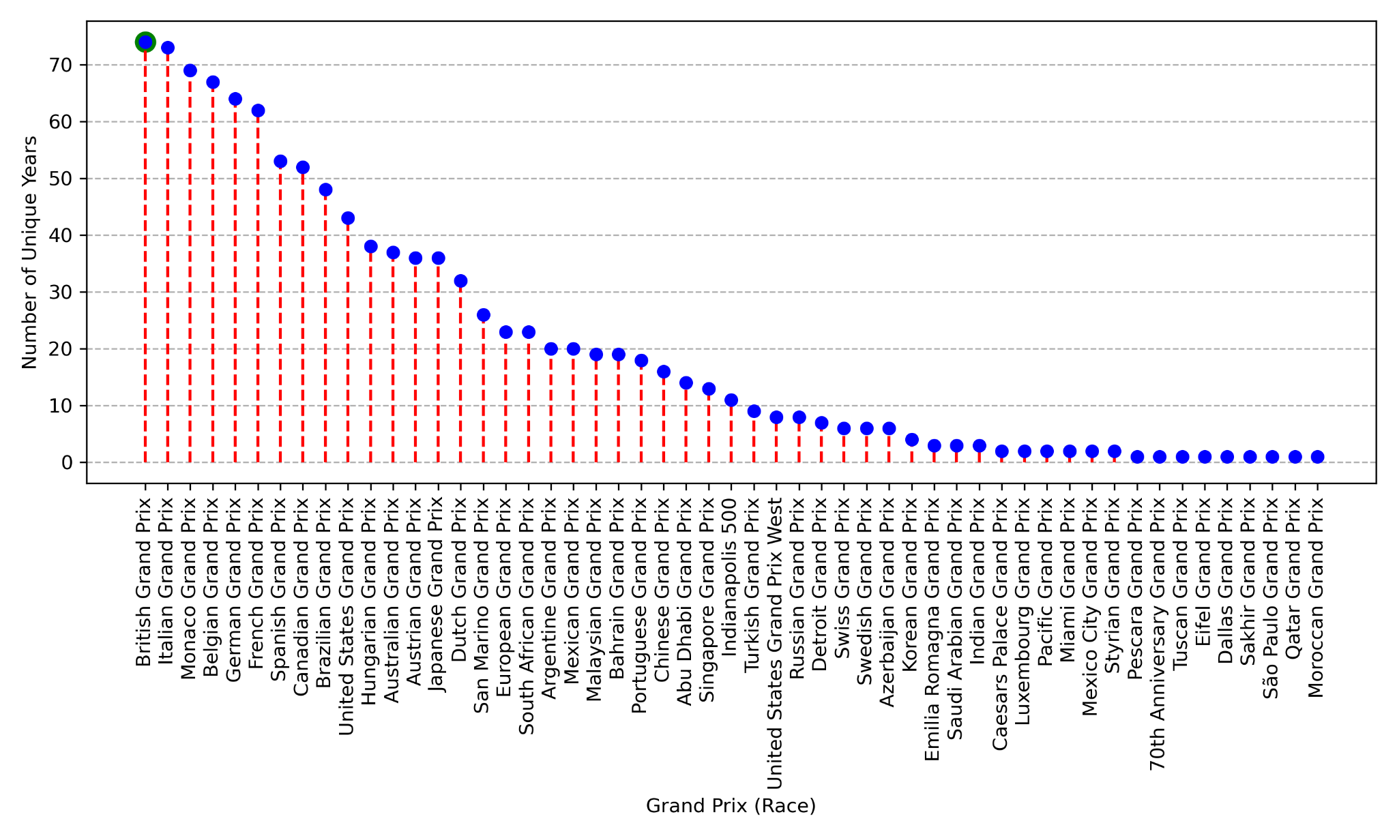

Figure 3. Number of races per track

The Silverstone track is the oldest track in the Formula One calendar and the United Kingdom is currently home to six out of the ten teams - Red Bull, Mercedes, McLaren, Aston Martin, Alpine and Williams. The reason for this is due to the abandoned airspaces post World War II and ex-RAF engineers being available to begin working in Formula One factories.

The number of races per season were raised as a point of concern for driver and team welfare last year. The demands on travelling the globe and transporting all necessary equipment require high-level planning and very little margin for error. The figure below emphasises the steady increase in the number of races throughout the years and the reduction of races in 2020 to seventeen as a result of the COVID pandemic. It also highlights that the current 2023 season is joint-highest with last season's calendar of 22 races.

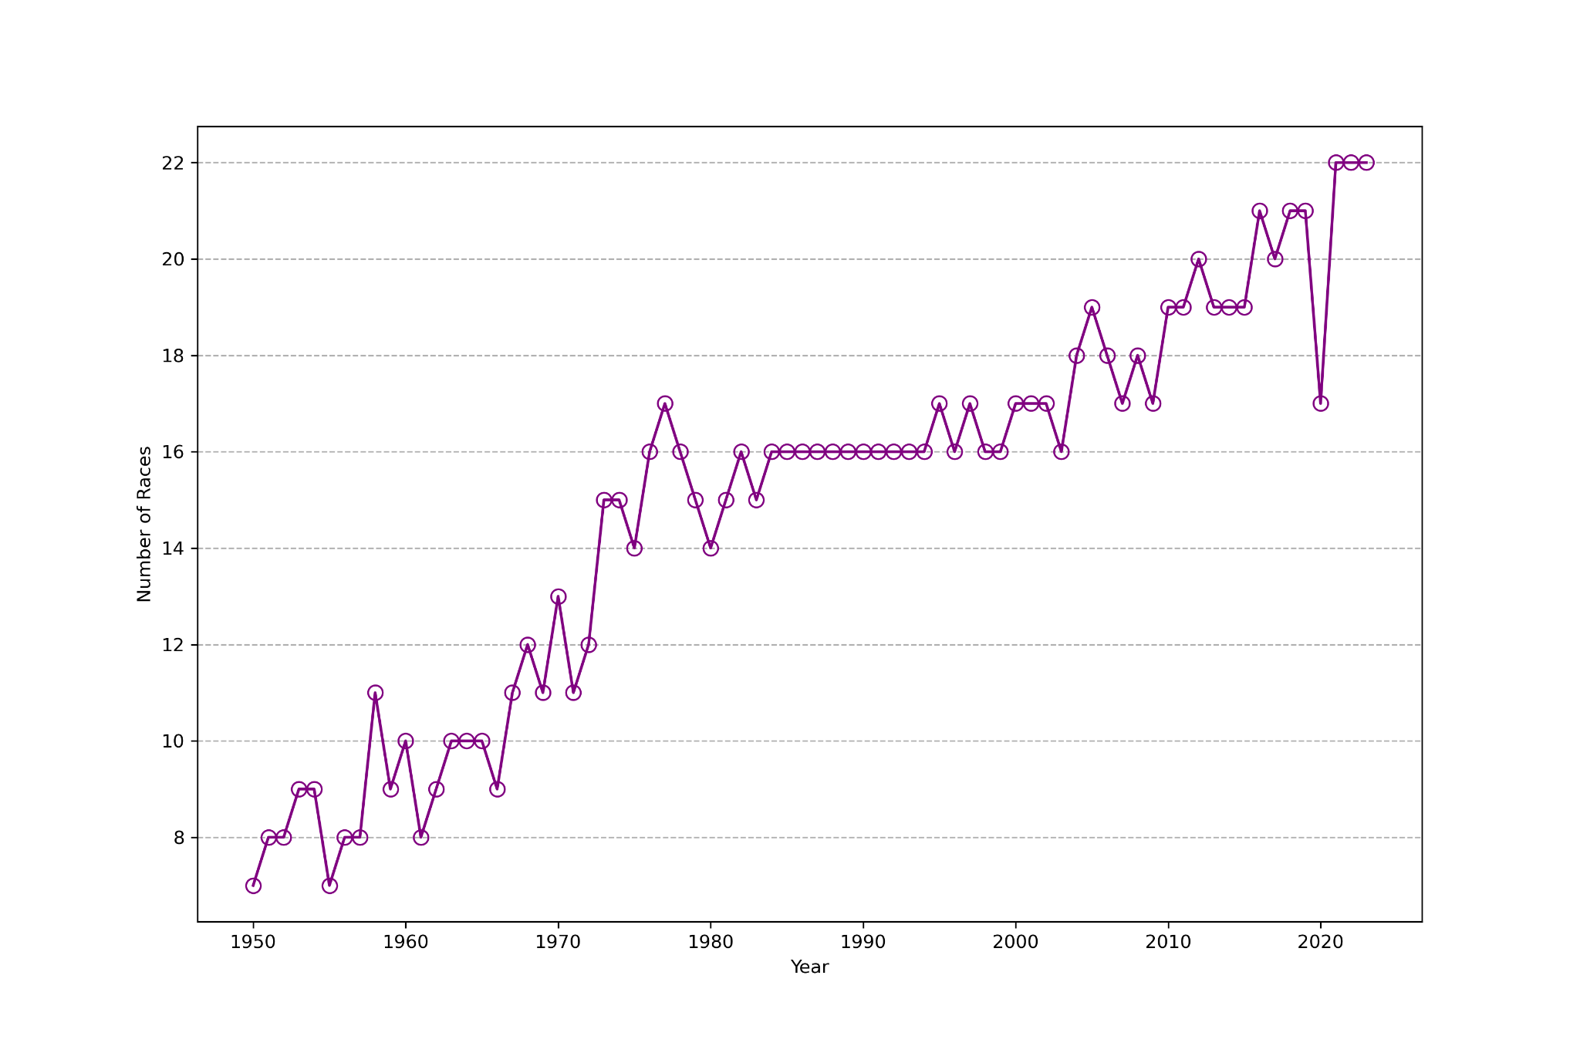

Figure 4. Number of races per season

In Figure 5, we observe the importance of starting from pole position in a race and the results earned by drivers when doing so. In most cases, starting from first place results in winning the race or otherwise, achieving second or third place.

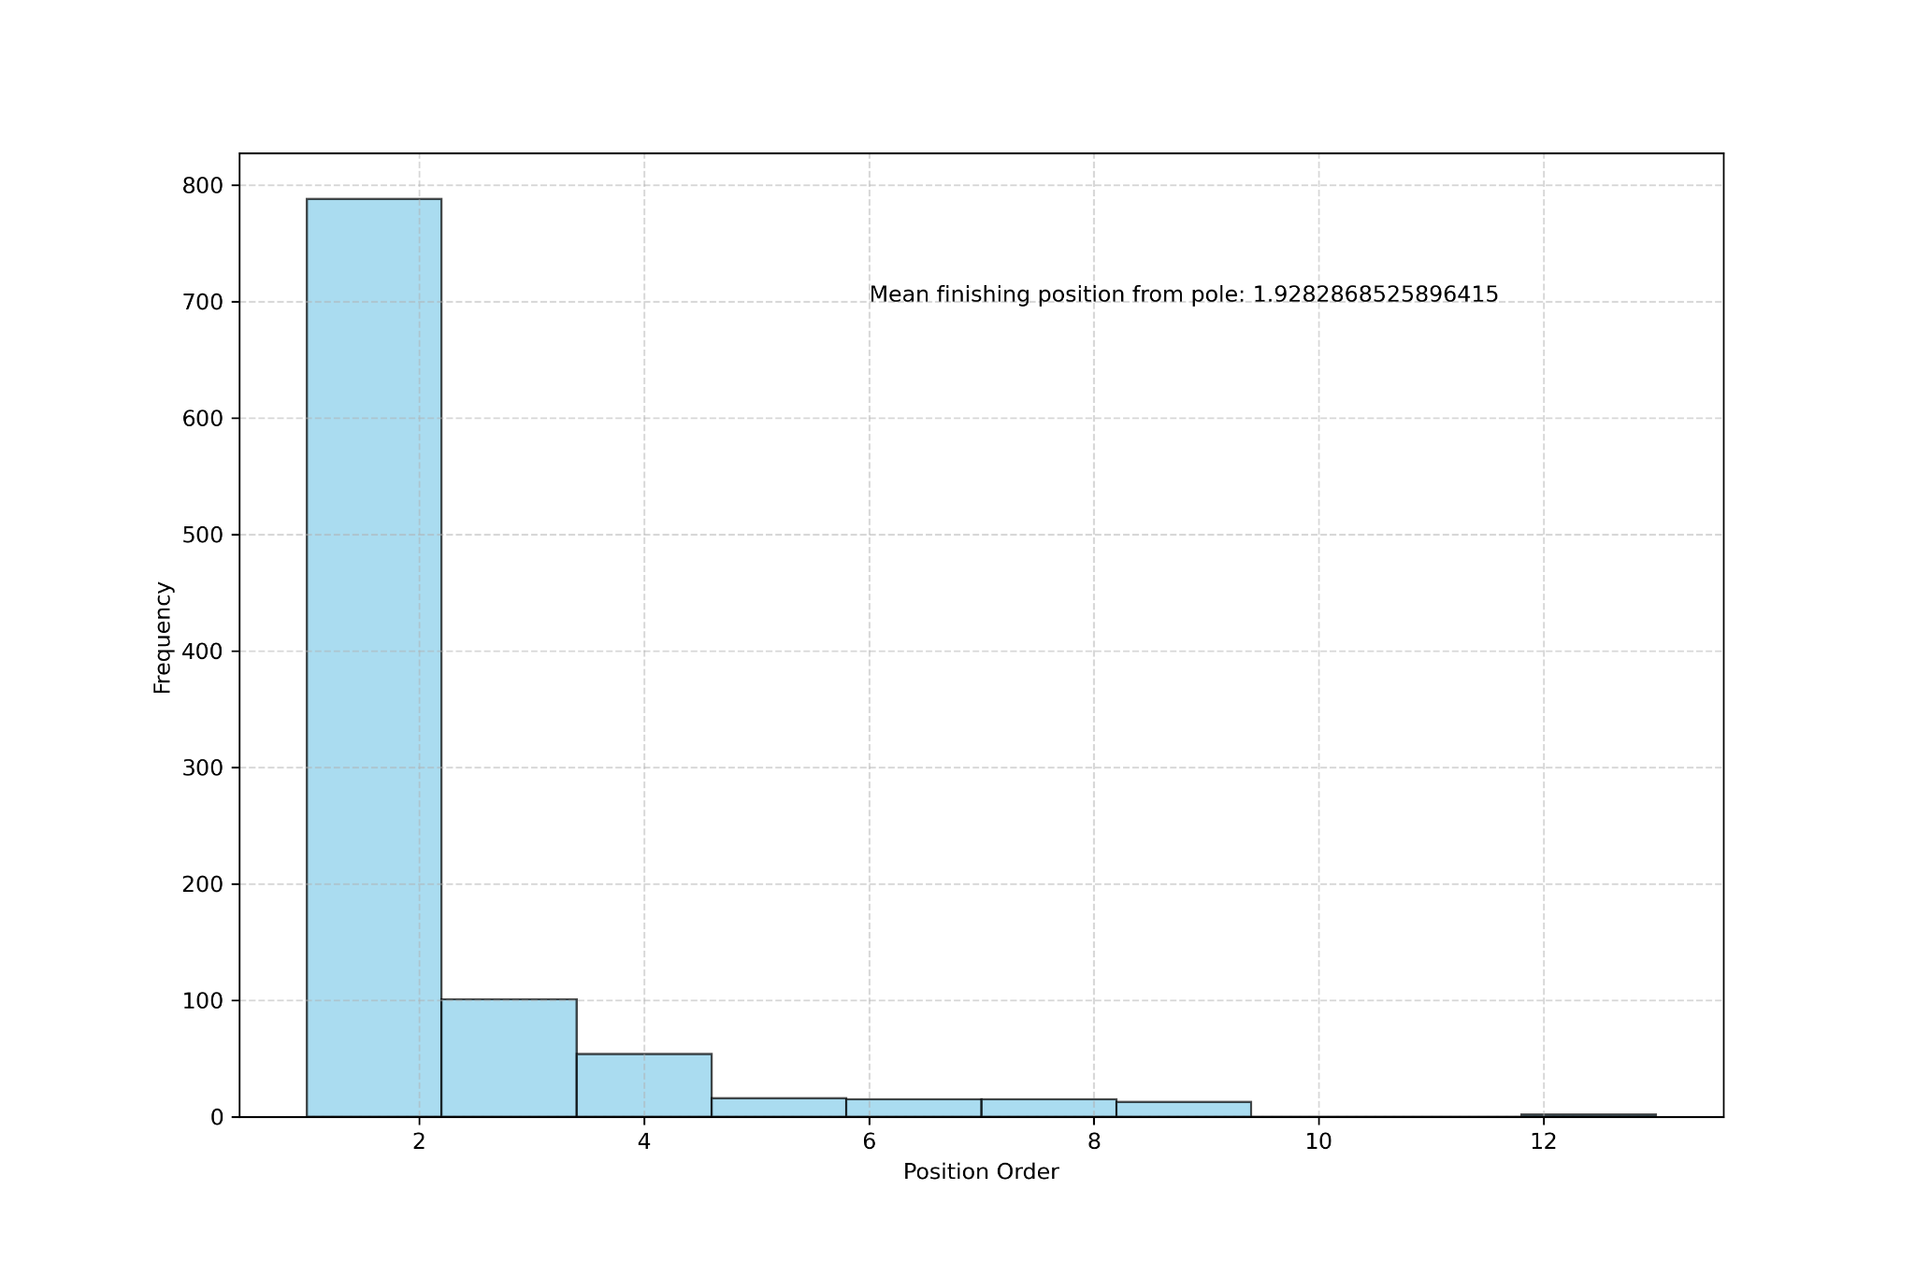

Figure 5. The importance of starting from pole position

Starting in pole position means that no other cars are in front of you to overtake and certain tracks are known to be difficult to execute overtakes during a race.

One such track is the Circuit de Monaco, which is a street circuit laid out around the city of Monte Carlo. The track is narrow and has tight corners as expected and is considered to be one of the greatest tests a Formula One driver will face.

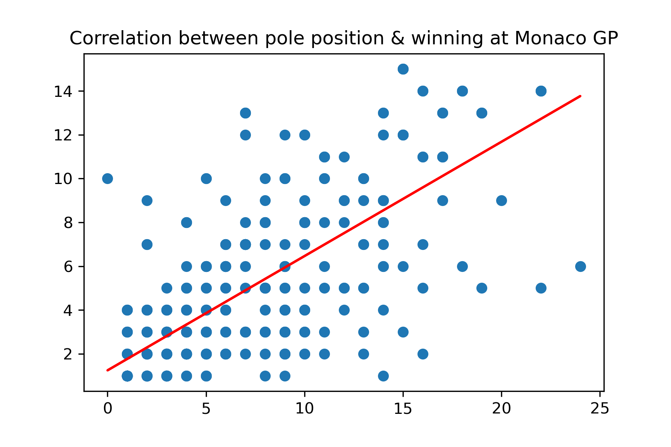

Figure 6. Correlation between pole position & winning at Monaco

The positive correlation between the starting position and results position shows the difficulties this track poses for drivers who need to overtake rivals to gain a position. However, the scatter plot shows variance in the results which can be attributed to the tight characteristics of the track and the likeliness of accidents or collisions occurring.

Figure 7 emphasises this as the Monaco race track has exactly 31 accidents or collisions more than the second highest track, Monza. These two tracks were in focus on Figure 3 as they topped the number of races run on a track so the accident rate is almost expected to be high in that respect. However, the horizontal bar plot shows Monaco to be clear of its race track partners and reinforce the testing nature of this track for drivers of all experience levels.

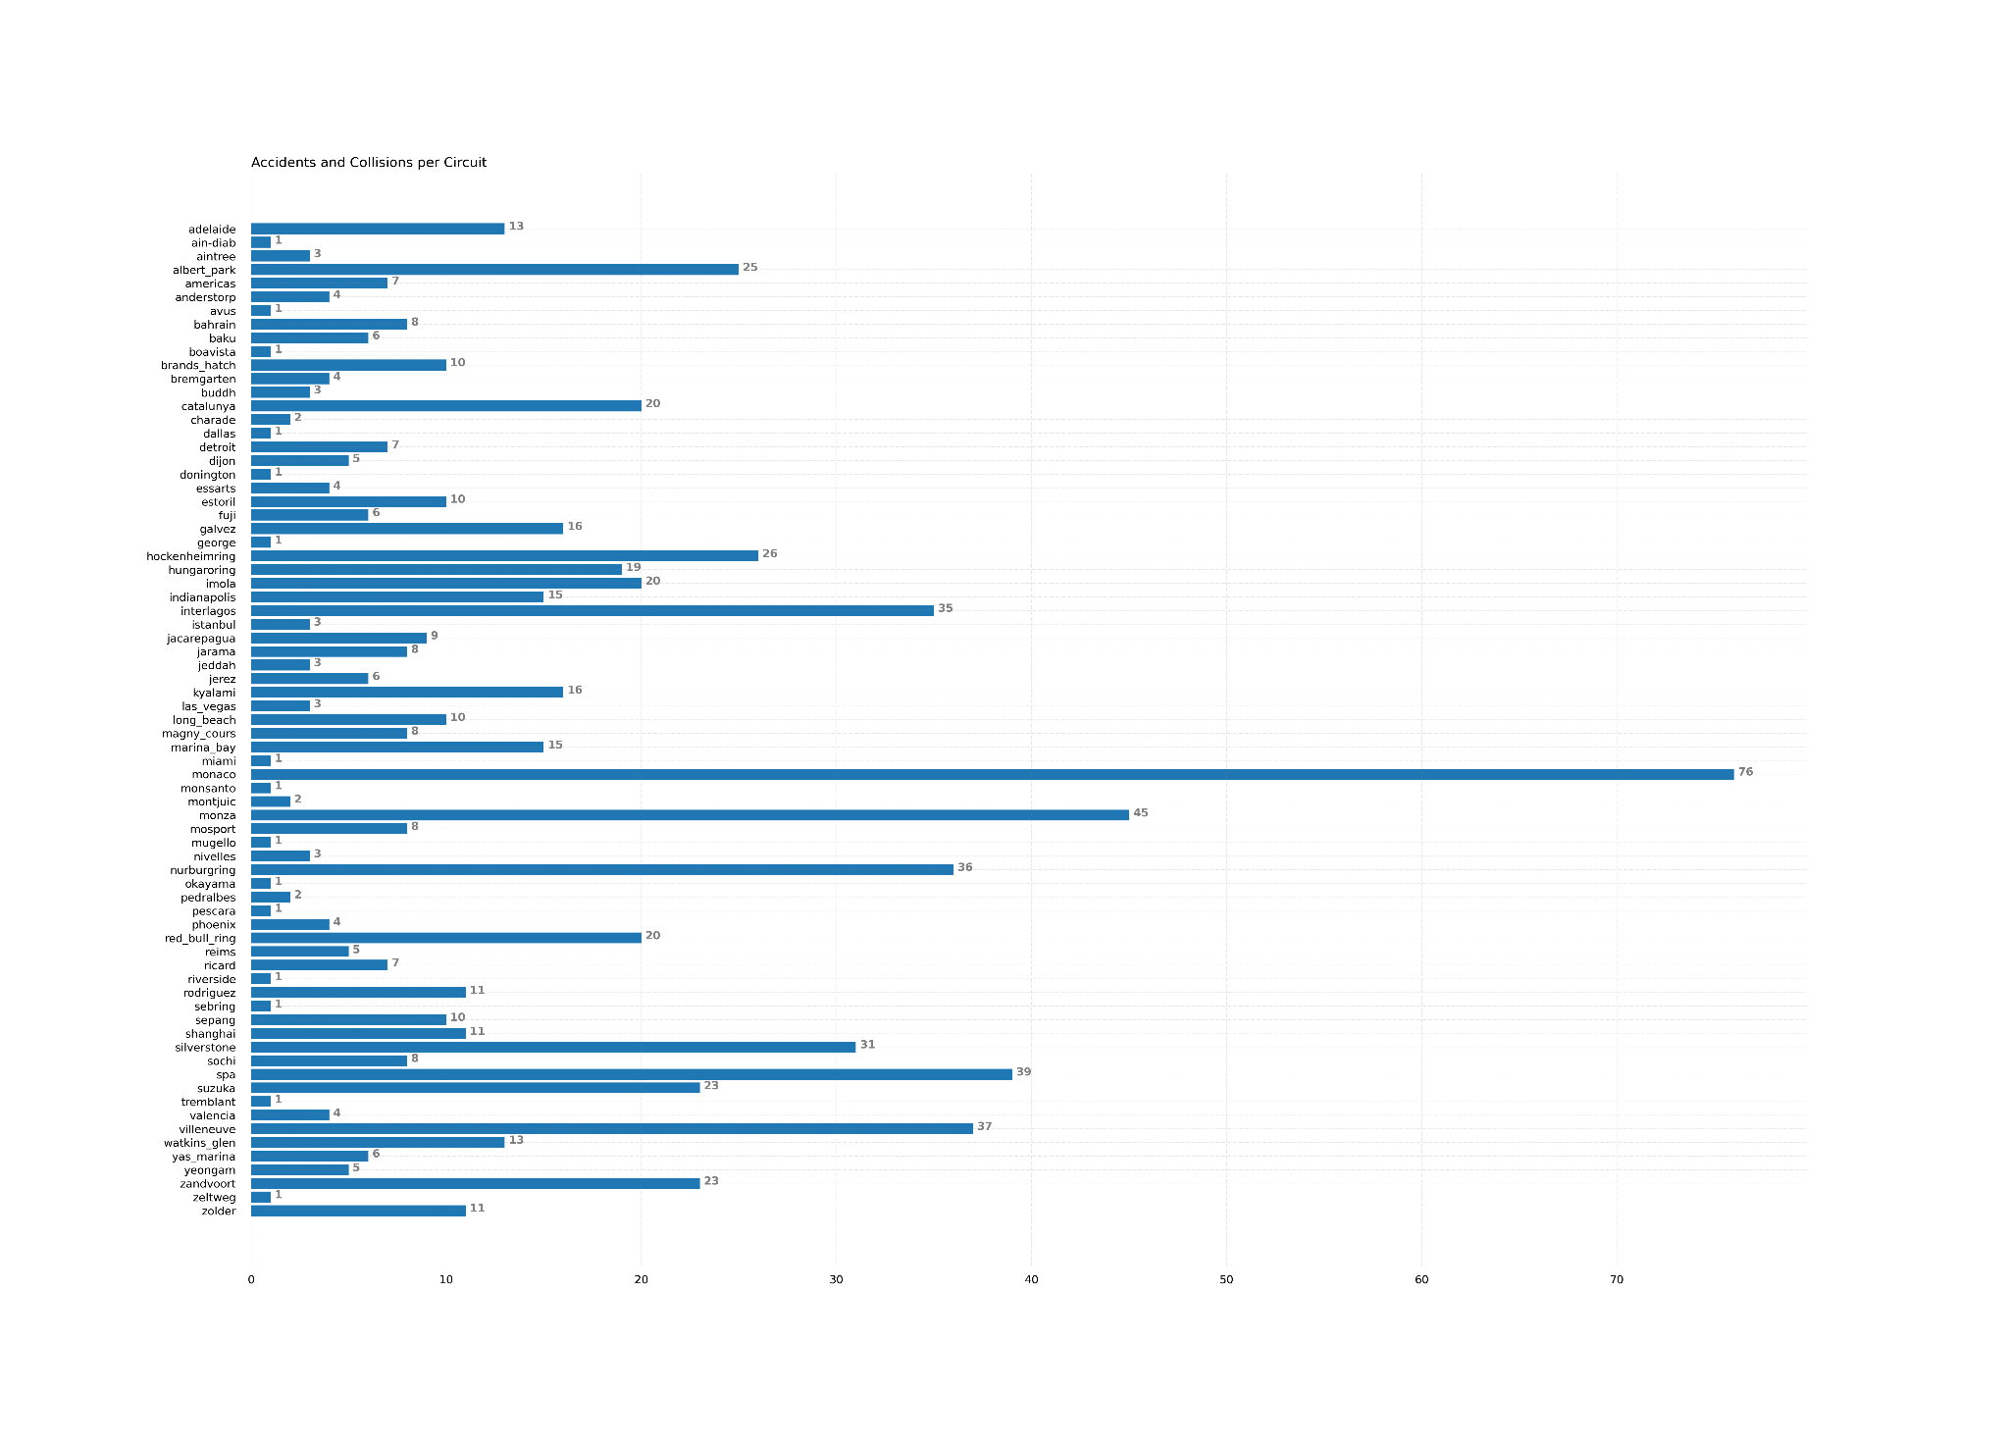

Figure 7. Accidents and Collisions per circuit

Formula One has seen notable regulation changes to reduce the number of accidents and collisions in a season. The introduction of the Halo safety device in 2018 marked a significant change in the safety of drivers from car debris or cars landing on top of one another during a race. The halo is a curved-bar that protects the driver’s head in the cockpit and weighs almost 10 kg to withstand impact and pressure where needed. The figure below shows a spike in accidents between the 2007 - 2010 seasons, with 2008 resulting in the highest number of accidents and collisions recorded in a Formula One season yet. Both the 2008 and 2010 seasons had 22 accidents and collisions recorded but a driver count of 368 in 2008 compared to 456 in 2010 led to the 2008 season having an accident count of 0.06.

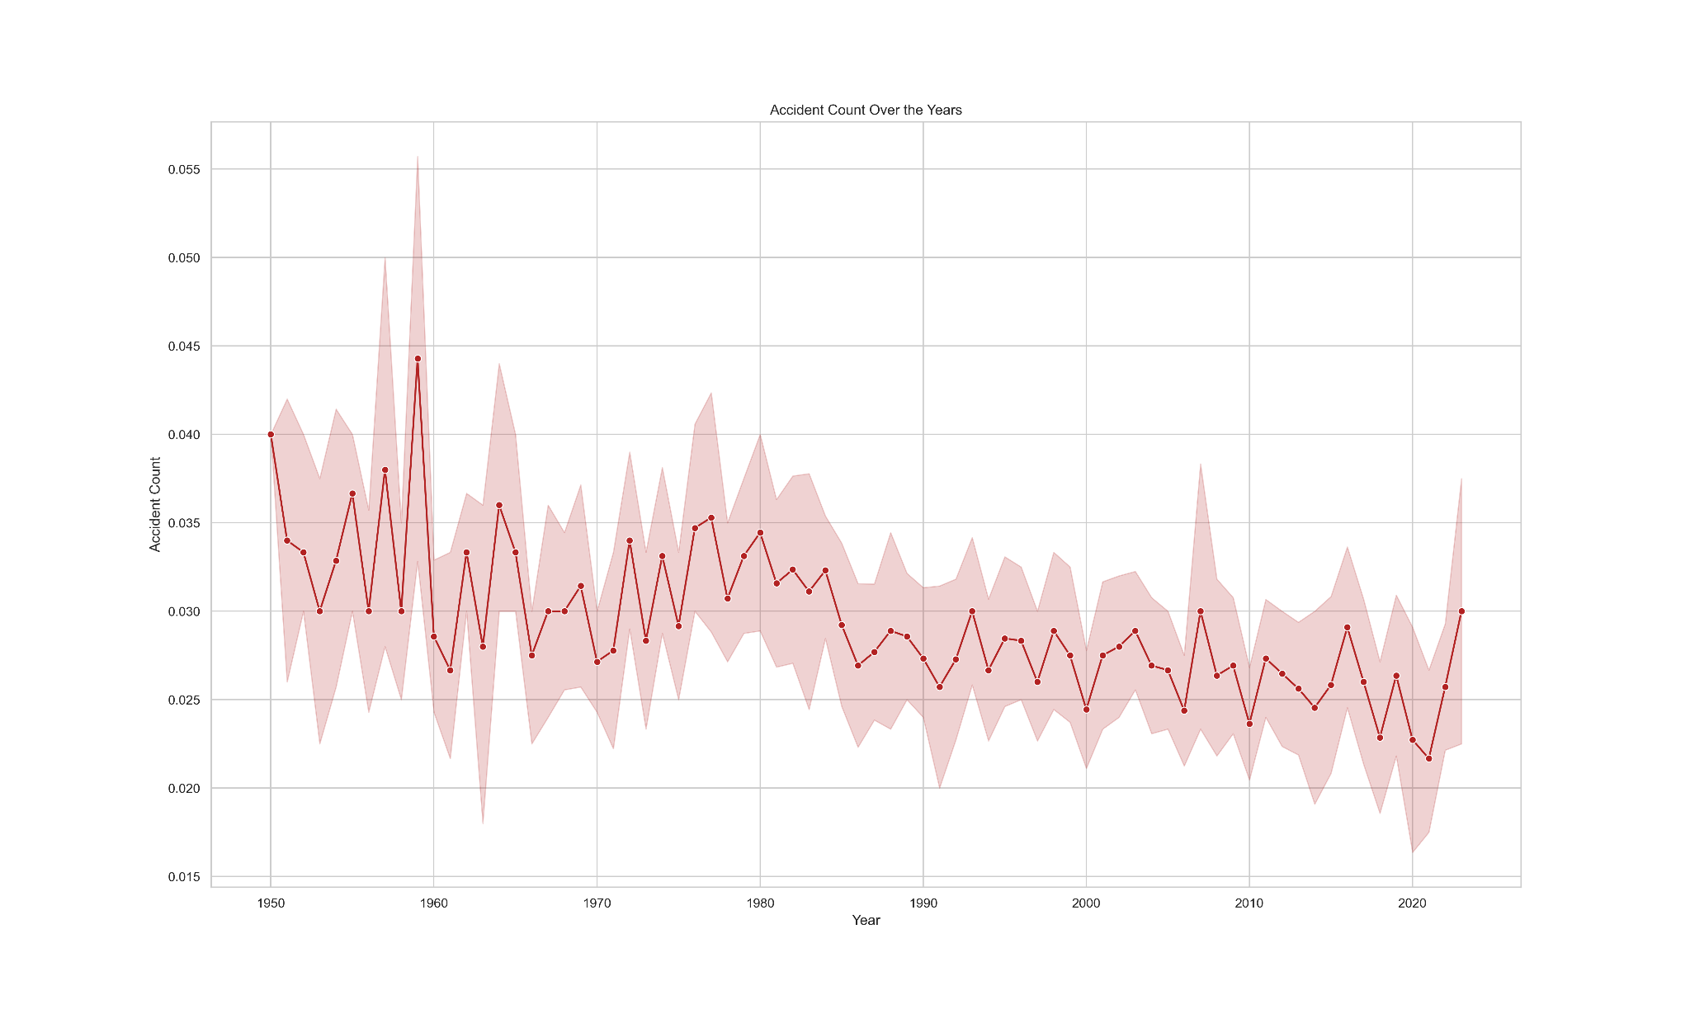

Figure 8. Accident rate per Year

Evaluating driver performance and consistency will be a key feature of the machine learning model’s ability to predict a race outcome. The figure below takes into consideration the number of wins, relative to the number of races competed, for each driver. The data shows that a five percent margin separates Lewis Hamilton, Michael Schumacher and Max Verstappen respectively. A similar gap is displayed between Max Verstappen’s win ratio compared to Fernando Alonso and after this, the percentage variance begins to decrease.

Lewis Hamilton is now the current all-time record holder with 103 wins but the data also highlights the explosive impact Max Verstappen has had on the sport given his debut was in 2016. The data also does not take into account that Max Verstappen is currently undefeated this season at the time of writing.

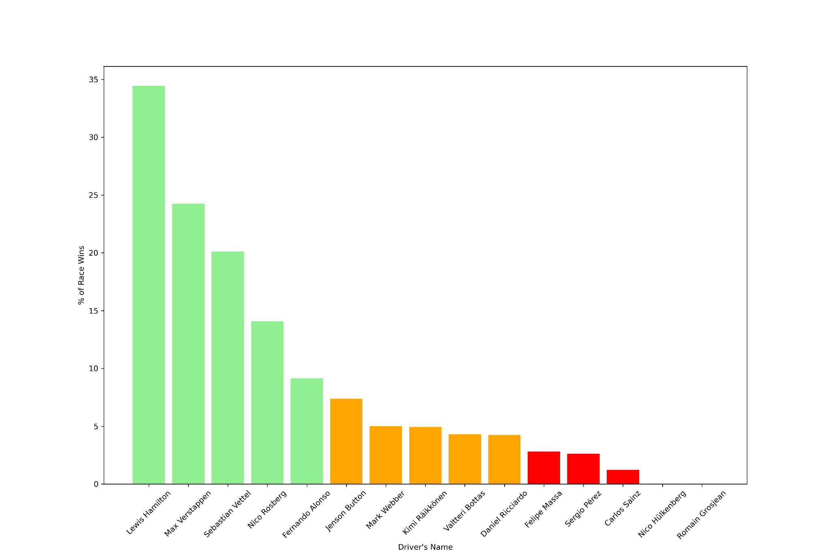

Figure 9. Percentage of wins per drivers (2002 - 2022)

#### *Missing Values*

Missing or corrupt data is all too common with real-world datasets and can induce biases in the data analytics if not addressed. There are ways to handle these potential problems such as treating them as null values or using imputation which predicts their value based on the existing values in the data.

The ‘Qualifying’ table shows missing values for the Q1, Q2 and Q3 variables. These represent the three stages allocated for grid position qualification for a driver before a race. Qualifying session one lasts for 18 minutes, session two lasts for 15 minutes and session three lasting 12 minutes. A break of seven and eight minutes are assigned to each car between these sessions and the fastest lap time recorded by each driver is taken as their qualifying time. The missing values here can be accounted for since a driver may crash the vehicle during qualification or suffer a performance failure in the car which results in forced retirement and incomplete qualifying rounds. An additional point to note here is the five slowest times in Q1 are eliminated from competing in Q2 and Q3, with the same rules applying for drivers moving from Q2 to Q3.

The figure below shows the ‘duration’ variable containing the highest percentage of missing data amongst all data tables. This represents the length of time for each car’s pit stop in a race and unlike the qualifying data, should have a record of each instance as the pit stop either occurs or not.

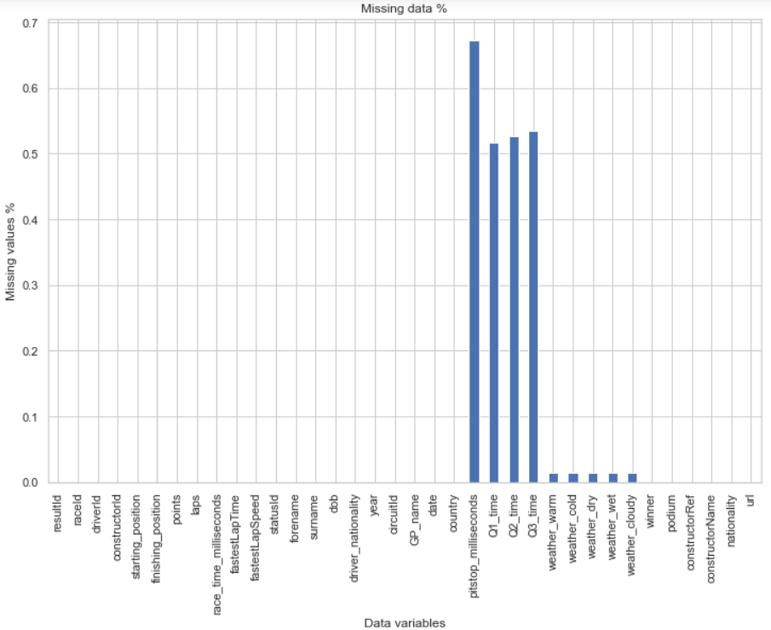

Figure 10. Percentage of missing data

### *Data Preparation & Feature Extraction*

The data preparation process is a critical stage in the machine learning workflow. It ensures data quality remains high and the necessary data transformation is performed before applying machine learning techniques. The data preparation and feature extraction began with the merging procedure of different datasets in Jupyter notebook. The basetable contains 31649 observations and 36 features in total. The overall success of this research will be examined on the data preparation techniques used, the features engineering from the data exploration and preparation process, and the model’s predictive power when the machine learning algorithms are applied. Below are the datasets loaded into the Jupyter environment for this process:

| Datasets |
| --- |
| Circuits |
| Constructor Results |
| Constructor Standings |
| Constructors |
| Driver Standings |
| Drivers |
| Lap Times |
| Pit Stops |
| Qualifying |
| Races |
| Results |
| Seasons |
| Status |
| Weather |

* *Weather*

All bar one of these datasets were extracted from the Ergast API. The final dataset in this list, the Weather dataset, required the assistance of the Python library BeautifulSoup in order to engineer the following features in the dataset.

| weather_warm | weather_cold | weather_dry | weather_wet | weather_cloudy |
| --- | --- | --- | --- | --- |
| 0 | 0 | 0 | 1 | 0 |
| 0 | 0 | 0 | 0 | 1 |
| 0 | 1 | 0 | 0 | 0 |

With reference to the first research objective of identifying the key features that can influence the result of a Formula One race, the weather for each race is an uncontrollable factor that can impact the progress of a driver. Almost all races in a given Formula One season take place under good conditions. However, a minority of these are run during bad weather conditions and this feature in the data requires engineering. The difference in rate temperature will be less significant under this binary structure.

* *Winner*

The primary goal of a race prediction model is to accurately predict the winner of a Formula One race. The winner feature directly correlates to the target variable of the finishing position and serves as a measure of success in the task at hand. A driver’s previous win history will represent a strong indicator of their skill, experience and team’s capabilities to provide the platform for a driver to achieve the greatest honours in a motorsport race. In addition to this, the winning history attached can reflect the strategic powers of a team and illustrate a driver’s ability to win future races from a prediction standpoint. This feature was engineered from the target variable, finishing position.

| Winner | |
| --- | --- |
| * Finished in first place = 1 | * Finished in any other position or did not complete the race = 0 |

* *Podium Finishes*

The next feature to be engineered in respect of my first research objective is identifying which drivers achieved a podium finish in each race. Success is defined as finishing in the top 3 of a Formula One race as these drivers are invited on the podium for recognition of their in-race performance. Similarly to the weather features, a driver who achieved a podium finish will get a ‘1’ and all other participants in that race will receive a ‘0’. This calculation is extracted from the finishing position data of each race and offers the machine learning models a data variable to identify drivers who are almost achieving race wins.

| Podium - Top 3 finish | |
| --- | --- |
| * Not finished in top three = 0 | * Finished in the top three = 1 |

* *Average Last 3 Finishes*

Both the winner and podium data features focus on driver’s in the upper echelon of the race standings and does not offer much insight into the improved or regressive performance of the other drivers on the grid. By curating an average last 3 finishes feature for all drivers, the machine learning models can interpret this data to predict their finishing position based on current form. If a newly-introduced driver is present, which is not uncommon in this sport given the development of Formula 2 (second-tier) and Formula 3 (third-tier), an average of ‘0’ is given until the necessary calculations are possible. This also provides an indication of the driver’s experience in the sport and can yield greater predictive power for the models.

| Average Last 3 Finishes | |
| --- | --- |
| * driverId = 14 * Three previous finishing positions = 6, 14, 9 | * Average Last 3 Finishes = 9.66666666667 |

* *Driver Years Experience*

Often a point referenced by Formula One pundits and fans throughout a season, experience leads to improved driving skills. Experienced drivers have a greater understanding of the complexities of a race, the technical performance of their car, and overall race strategy. By creating this feature variable, a driver's racecraft and ability to make fewer mistakes is acknowledged and can result in more consistent point-scoring performances which will be useful for the predictive model.

| Driver Years Experience | |
| --- | --- |
| * driverId = 4 * Driver Debut Year = 2001 * Specific year of race = 2008 | * Driver Years Experience = 7 |

* *Driver Circuit Experience*

Similarly to the Driver Years Experience feature, a driver’s circuit experience in Formula One racing can have a substantial impact on the result of a race. The maximum performance of a car can be achieved through a driver’s understanding of the best racing line on a track, where the best braking points are per turn, and where the best overtaking opportunities are to gain a position in a race. Other strategic nuances can be included in this which may not be incorporated in the present datasets and this feature offers further context for the predictive models to achieve the research objective of identifying key features which can influence the result of a race.

| Driver Circuit Experience | |
| --- | --- |
| * driverId = 825 * circuitId = 14 * driverId & circuitId returns 9 records | * Driver Circuit Experience = 9 |

* *Constructor Wins*

This feature has been created to provide context around the overall performance of a team’s car and strategy in a given season. The constructor’s championship is a prestigious achievement in Formula One racing and points to them being consistently competitive throughout the season. It can represent the technical expertise, elite strategic capabilities in a race and a level of competitive advantage against the field for any given season. From a race prediction standpoint, it can contextualise a dominant team and highlight the potential performance of both drivers for that team before a race.

| Constructor Wins | |
| --- | --- |
| * driverId = 825 * circuitId = 14 * driverId & circuitId returns 9 records | * Driver Circuit Experience = 9 |

The raw data comprises categorical, numerical, binary and datetime variables which require manipulation in order to be presented to machine learning models.

### *Modelling*

The Formula One racing dataFrame created from the ‘Data Preparation & Feature Extraction’ step has been prepared for machine learning modelling. Selecting the models to use in this experimentation is important and can be aided through past studies and successful models included in these papers.

The prepared dataset is transformed into a 70% training dataset and 30% testing dataset, with the 30% validation dataset providing our prediction score per model. This training data did not include the points feature variable to include an additional layer of complexity to the prediction challenge proposed. The points variable provides a linear relationship to the finishing position of a driver in a race as the highest points allocation of 10 within a race result

#### *Linear regression*

Linear regression is a fundamental and versatile predictive modeling technique which assumes a linear relationship between a dependent variable, the outcome we aim to predict, and the features provided. This type of machine learning serves both simple and complex patterns in the data and indicates their strengths and impact on the outcome returned.

This regression model is chosen due to its ability to learn the coefficients that best represent the relationships between features such as the starting position of a driver in a race, or their performance in previous races, with the race outcome achieved. To expand on the previous sentence, there is often a linear relationship between the starting position and finishing position of a driver in a race. Those at the front of the starting grid tend to have a higher probability of finishing in the top-half of the result standings and this was previously represented in Figure 5 of the Data Exploration section.

#### *Random Forest regression*

Ensemble learning methods utilize multiple machine learning models to increase prediction accuracy in comparison to an individual model. The power of these methods come in the shape of training multiple models on different subsets and achieve these higher accuracies through leveraging the collective wisdom of the multiple models. It is here that Random Forest regression can combine the principles of ensemble learning through building many decision trees as a whole to provide this premium prediction accuracy.

A random forest model is constructed on the fundamental idea of bootstrapped training samples. This technique engages with slightly different training samples to result in each returned sample being replaced from the training data. Consequently, the grown trees of the random forest model are built on a different training sample and correspond to a decorrelation between all trees. The model only uses a subset of predictor variables at each node and gives rise to the random element of this model's name.

The RandomForestRegressor() is fitted with default hyperparameters initially and begins learning from the training data by building an ensemble of decision trees. A parameters dictionary is created to define a grid of hyperparameters to explore. The first hyperparameter, n_estimators, determines the amount of decision trees to be included in the ensemble. This value can test the balance between increased model robustness and training time. The second parameter, max_depth, defines the number of levels in each decision tree and the model complexity. The third hyperparameter, min_samples_split, prevents small partitions being created in internal nodes and reduces the introduction of noise in the data. The final parameter, min_sample_leafs, determines the sample depth for a prediction node and helps to increase partition size, thus encouraging robustness in the model.

GridSearch cross-validation is introduced to find the best parameters here to systematically search through the values proposed and evaluate the model’s performance with these instances. Cross-validation once again ensures robustness and the metrics generated at each round form the optimal hyperparameters to maximize performance and minimize a loss function.

The best parameters are imputed into the Random Forest regression model from the tuning process and metrics such as the Mean Squared Error, Root Mean Squared Error, R-squared value and Mean Absolute Error assess the quality of predictions and overall performance of this regression model.

#### *XGBoosting*

#### *Decision Tree regression*

To compare this regression model with the Random Forest model, regular decision trees face greater variance and overfitting issues based on the model ensemble. The random forest model is expected to offer a higher predictive power than a single decision tree.

#### *K-Nearest Neighbor*

#### *Long Short Term Memory*

Recurrent Neural Networks (RNNs) specialise in processing sequential data through the sharing of parameters and statistical strengths. This helps the model to generalise time series data of different lengths.

When considering the application of a recurrent neural network to Formula One, data such as the race results, lap times and driver performance are often organized in a sequential manner and analyzed over time. These trends and patterns can facilitate race or seasonal analysis of a driver’s performance and constructor’s strategies.

A Long Short Term Memory (LSTM) neural network is developed with LSTM layers and various functions such as the mean square error, mean absolute error and R2 score to measure the model’s accuracy in predicting a race outcome. Mean Squared Error (MSE), for example, is a common choice of loss function for regression tasks and provides a comparison of loss between the prediction and true values. The model implementation is configured using the TensorFlow Python library and Sequential() class to complete a sequential model build. The Long Short Term Memory was applied to the model using the add() function, with a hyperparameter search created through the Keras Tuner for a minimum of 32 units and maximum of 256. This corresponds to the number of memory cells or neurons assigned to the LSTM layer. The memory cells of a Long Short Term Memory model have three main components: an entry gate, a forget gate and an exit gate. These gates regulate the flow of information through the cell and control the information passed to the next cell. The implementation of a maximum of 256 units allows the model to increase computational complexity and find the optimal number of units based on the dataset present and hyperparameter search.

The Rectified Linear Unit (ReLU) function replaces negative values with zero and leaves positive values unaltered. Through this, the activation function can learn complex relationships in the data and introduce non-linearity to the model. The model architecture includes a dense output layer with one neuron to predict a numeric value. This is the goal of the regression task at hand and the dense output layer represents the final layer responsible for this.

Fitting the training model with the corresponding data begins with the application of the fit() method. To ensure that the data conforms to the shape required by the Long Short Term Memory model, a transformation method values.reshape() is applied to both the training and test sets. A regularization technique called dropout is also applied to alleviate overfitting and has parameters between 0.0 and 0.5 (50% dropout) for the tuner to produce the best rate for the model.

During training, the model adjusts the network weights during each epoch with the assistance of the Adam optimizer. With the epochs set to 50, the model will go through 50 iterations of the full training set. The higher the number of epochs used in this instance can lead to an increase in the possibility of overfitting the data, however, the use of the Adam optimizer helps to reduce this within the model.

The model’s prediction quality is being calculated through various metrics such as the root mean square error (RMSE), mean absolute error (MAE) and coefficient of determination (R2).

### *Model Evaluation*

Within this section, the performance models are compared based on their prediction metrics of the unseen test data.

A Naive Baseline model was built to act as a benchmark for the machine learning models used in this test. The baseline model makes predictions using minimal or no machine learning techniques but provides a reference to the performance any predictive model should exceed to be considered useful in analyzing Formula One data. The Naive Bayes model relies on the strong, but unrealistic, assumption that there is no correlation between the features within a dataset and are independent of each other. With this computation, the model is expected to be less accurate than the models presented later. The metric scores such as the mean squared error, root mean squared error, coefficient of determination (R2) and mean absolute error can confirm if the machine learning models used are adding value to the prediction process. The following scores were achieved by the Naive Baseline model:

| Mean Squared Error | 33.22 |
| --- | --- |
| Root Mean Squared Error | 5.76 |
| Coefficient of Determination (R2) | 0.00 |
| Mean Absolute Error | 4.95 |

A Mean Squared Error result of 33.22 indicates that substantial differences exist between the observed and predicted values of the model. The Root Mean Squared Error score of 5.76 also shows below-average performance between the target variable and model prediction. The Coefficient of Determination value of 0.00 clearly indicates the lack of variance understanding from the Naive Baseline model to interpret the features for target prediction. Similarly, the Mean Absolute Error is returning an average of 4.95 units adrift of the prediction outcome.

Frank, Trigg, Holmes, Witten [75] examined the relationship between the simplicity of the Naive Bayes learning model and the prediction accuracies in comparison to more sophisticated models. The experiment found that this model performed comparably to linear regression in terms of the absolute error of the predictions, but notably worse in respect of the squared error and any weighted linear regression models.

#### *Mean Squared Error*

The mean squared error assesses the average squared residual between the observed and predicted values. The formula for calculating this metric is as follows;

$MSE =\frac{Σ(yi − pi)2}{n}$

* yi represents the observed value
* pi represents the predicted value
* n represents the number of data observations
* $Σ$ represents the summation of all values for i

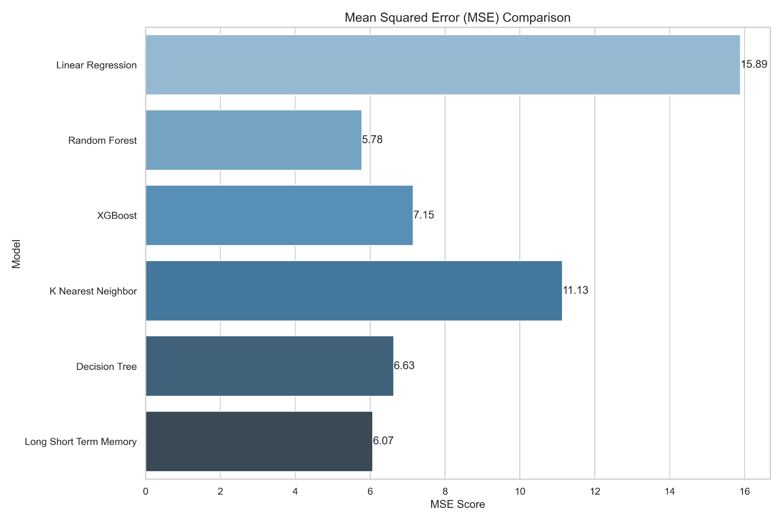

Figure 11. Mean Squared Error Comparison

The above figures shows that the Linear Regression model has the highest MSE score amongst the models evaluated. A score of 15.83 implies that the Linear Regression model deviates from the actual values by a relatively large amount. Suboptimal predictions here could be explained by the non-linear relationships assumed by the model to predict the outcome of a race from the underlying data. A driver experience feature was created for this model to account for improved race strategy and ability to make fewer mistakes but this does not always lead to a fixed increase in results. Novice drivers may experience significant gains in their early years based on natural talent that would defy a linear progression.

The K-Nearest Neighbor MSE score also suggests that the model did not effectively capture the patterns and underlying relationships in the test data. This model assumes that nearby data points have similar target values but given the nature of the sport and the minutiae differences that can significantly change a race outcome, this can lead to predictions that are far from reality.

The XGBoost model noticeably outperformed the Linear Regression model in this Mean Square Error score. Gradient boosting techniques are effective at capturing non-linear relationships and interactions between features which can be a noteworthy comparison between the MSE scores of both models. Within the analysis of the Linear Regression MSE score, the driver experience feature was highlighted as being potentially non-linear. Boosting techniques can handle feature interactions such as the type of track or weather conditions to utilise this driver experience feature compared to the Linear model.

The Decision Tree and Long Short Term Memory MSE scores returned similarly, 6.63 and 6.07 respectively. From a testing perspective, Decision Tree models have a propensity to overfit the training data and fail to generalize well to the corresponding test data. The score of 6.63 here suggests that the model exhibited some overfitting tendencies The introduction of pruning techniques in future research to simplify the model and remove overly specific branches in the tree structure can help mitigate overfitting.

The Long Short Term Memory model was the second best model in this metric comparison. This recurrent neural network (RNN) is well-suited for handling sequential data and time dependencies. In the context of Formula One, where data such as lap times and pit stops can have an impact on the overall outcome, the model captures these dependencies well.

Finally, the Random Forest model’s MSE score of 5.50 signifies that its predictions, on average, are closest to the actual race outcomes when compared to all other models. This results places a focus on the strength of the model’s ensemble learning method and the robustness it presents to reducing overfitting and model intricate patterns in the data.

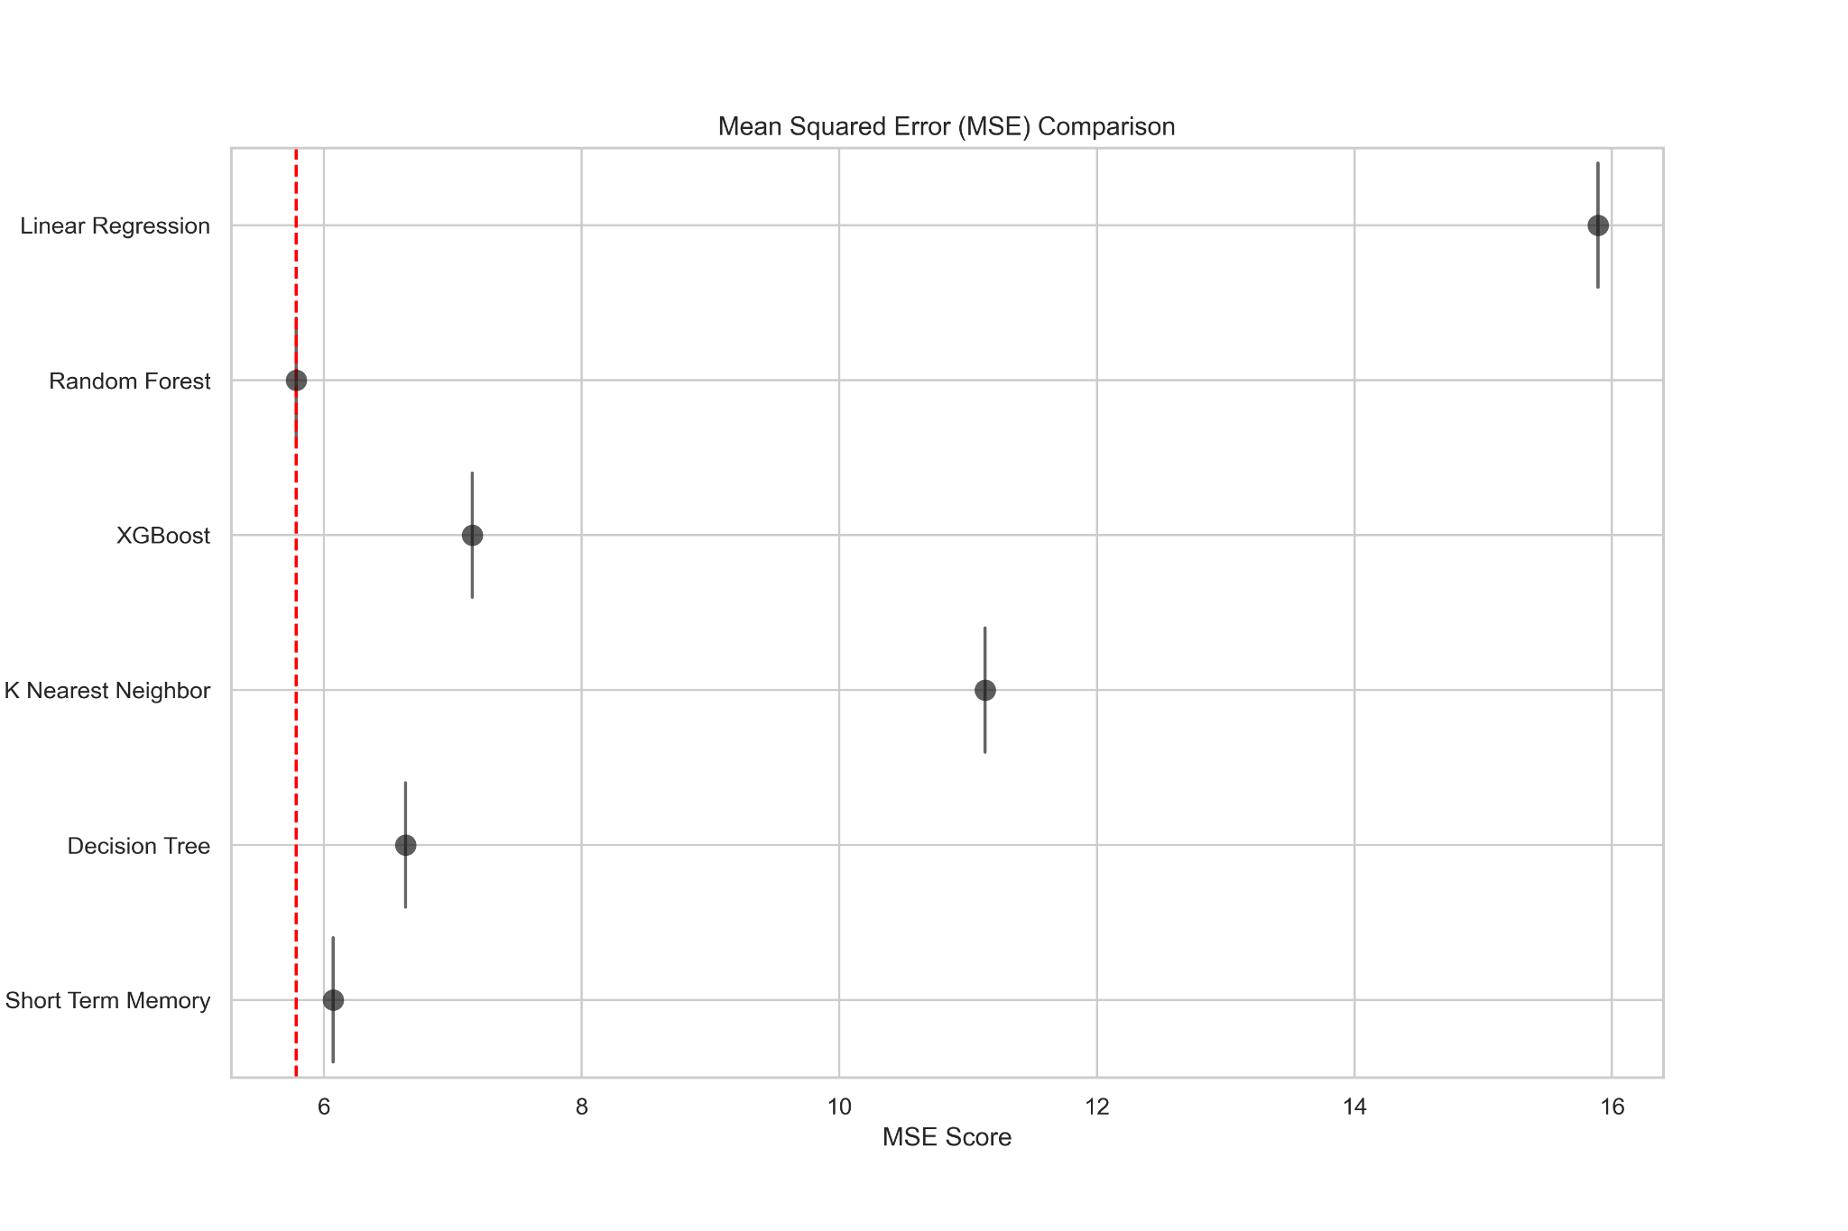

Figure 12. Optimal MSE Score Comparison

#### *Root Mean Squared Error*

To provide a measure of prediction error in the same units as the target variable, the finishing position, a root mean squared error test was conducted. This metric is often preferred to understand how far off the predictions were on average. In comparison to the mean squared error, outliers in the predictive model are less sensitive as the errors are not squared here. The formula for calculating the root mean squared error metric is as follows;

$RMSE = \sqrt{\frac{Σ(yi − pi)2}{n}}$

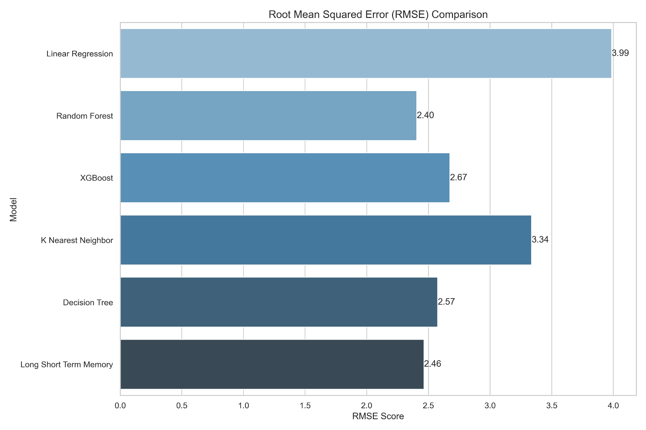

Figure 13. Root Mean Squared Error Comparison

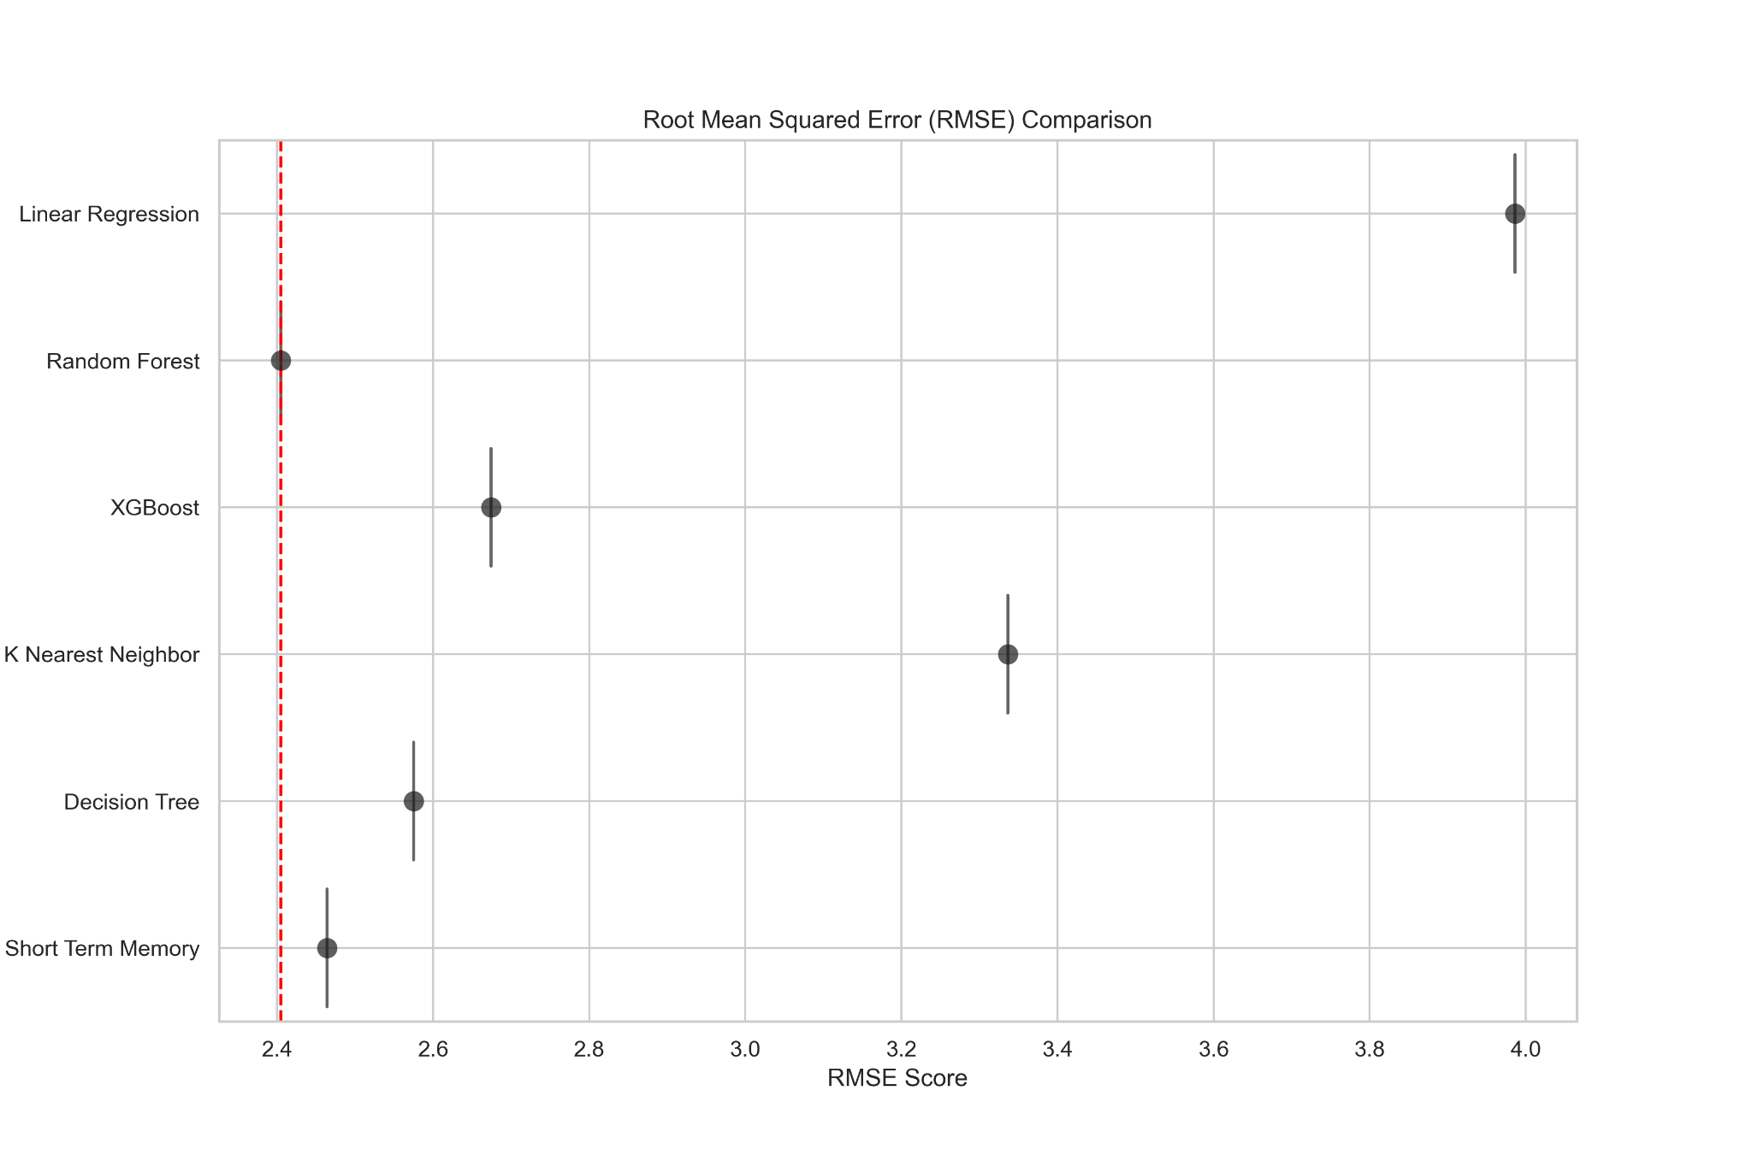

Figure 14. Optimal Root Mean Squared Error Score

*R-squared (R2)*

The ‘goodness’ of a model’s fit to the test data is quantified through this coefficient of determination metric The proportion of the total variance in the target variable that is explained by the independent features in the model are ranged from 0 to 1 here. .

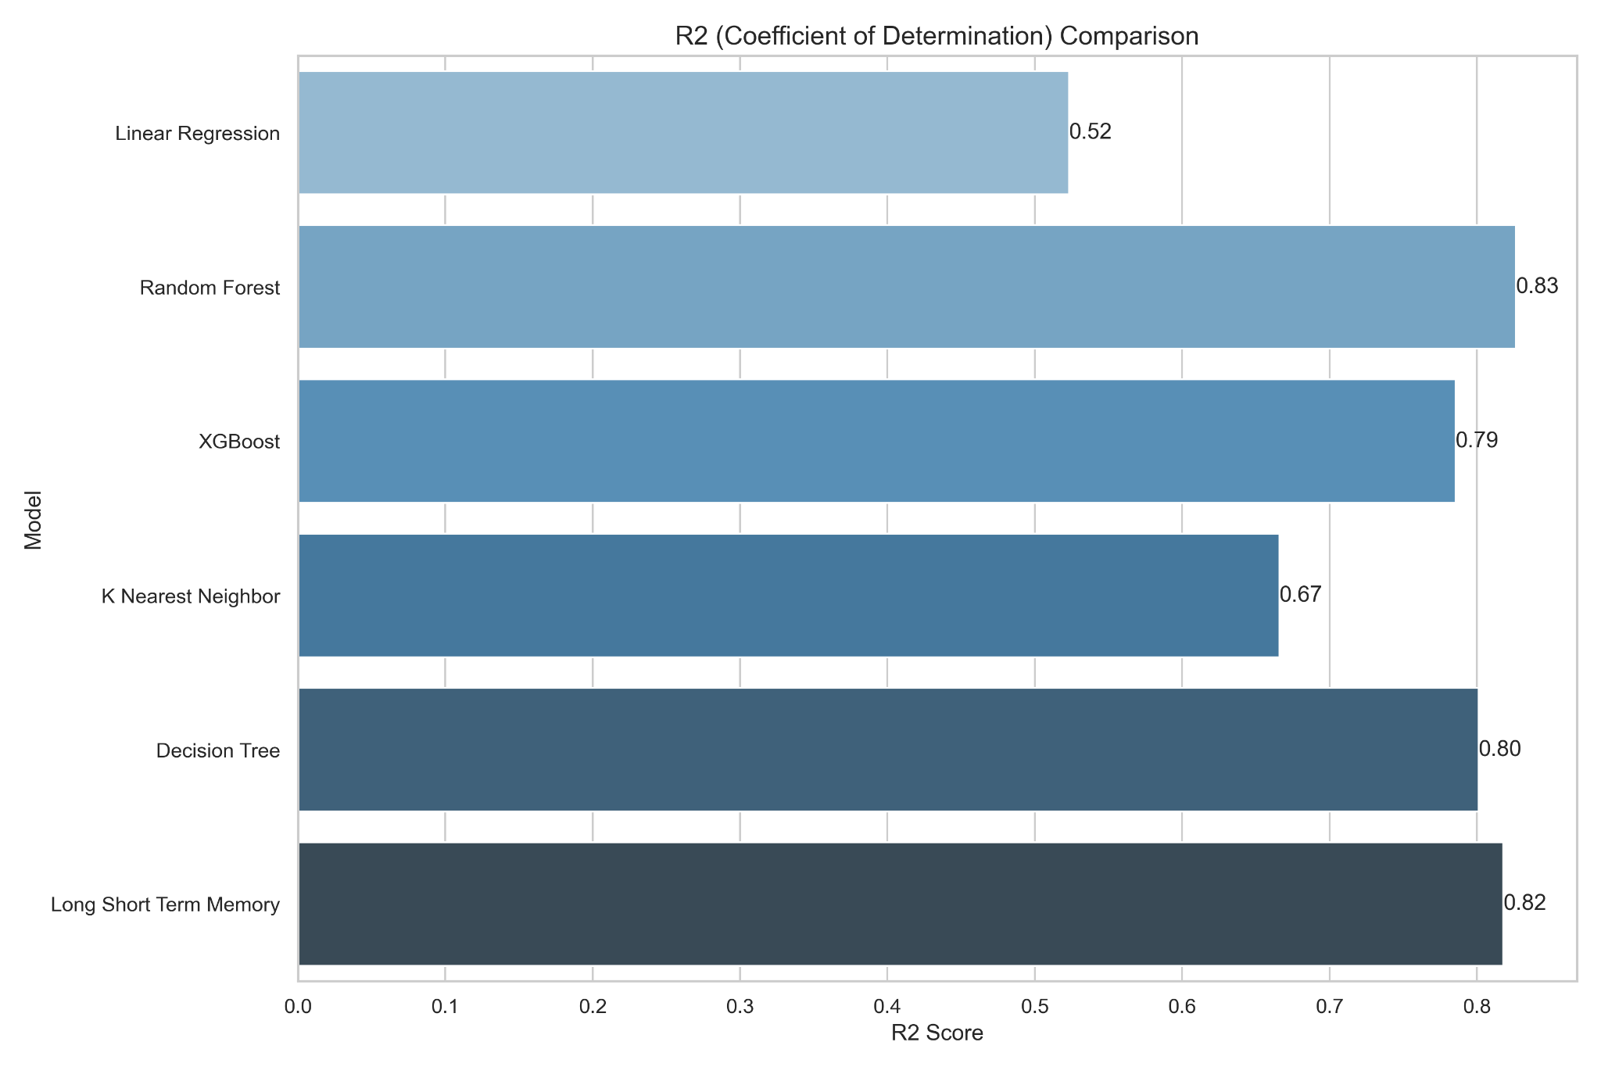

Figure 15. R-Squared Comparison

The Linear Regression model achieved a score of 0.52 here which corresponds to its relatively low scores in the mean squared error and root mean squared error metrics. This score suggests that it captures some, but not all, of the variance in the data. As mentioned previously, the assumption that all data features have a linear relationship can lead to a reduced score. When focusing on features such as the starting position, specifically pole position as examined in the data exploration phase, we can see a relative linear relationship with the finishing position target variable. However, this is just one variable within the dataset where underlying relationships can lead to greater predictive power.

The K-Nearest Neighbor model achieved an R-squared score of 0.67. An approximate explanation of two thirds of the variance in the target variable is accounted for here. An omission of 33% of the variance in the target variable leaves unexplained variance in the model and for professional deployment, this points to features not being considered by the model.

The four remaining models within this test are aptly spread by 4% in their score metrics. The close proximity of each model’s score in this instance points to a strong explanatory power amongst the models. Explanatory power is both increased and achieved through feature engineering and hyperparameter tuning from the outset. In summary, the Random Forest model best explained the variance in the target variable and has outperformed all other models in the tests so far.

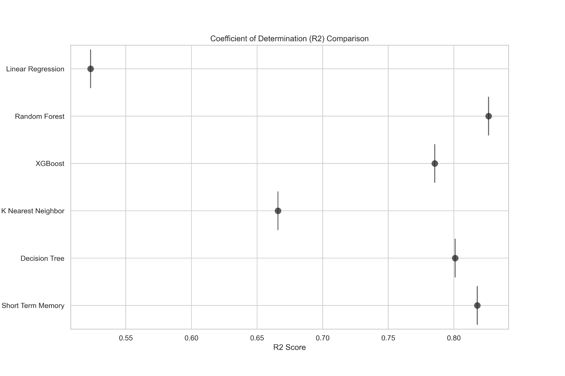

Figure 14. Optimal R-Squared Score

*Mean Absolute Error*

The Mean Absolute Error (MAE) score measures the average absolute deviation between the predicted and actual values. When looking for the desired lower MAE score in this instance, both the Decision Tree and Long Short Term Memory models achieve almost similar results. In the context of achieving the best possible race prediction outcome, both models return higher predictive power in terms of finishing position and overall race times. The mean absolute error formula is calculated as follows;

$MAE =\frac{Σn(yi − xi)}{n}$

* yi represents the predicted value
* xi represents the true value
* n represents the number of data observations
* $Σ$ represents the summation of all values for i

The Random Forest model returned a mean absolute error score of 1.52 which is closely behind the top 2 models. For the task of predicting race outcomes, this metric score shows that the model is capturing important patterns in the data. However, the Decision Tree and Long Short Term Memory models achieved the lowest MAE scores and provide a more reliable option for analysts in the Formula One world to improve race planning and strategy.

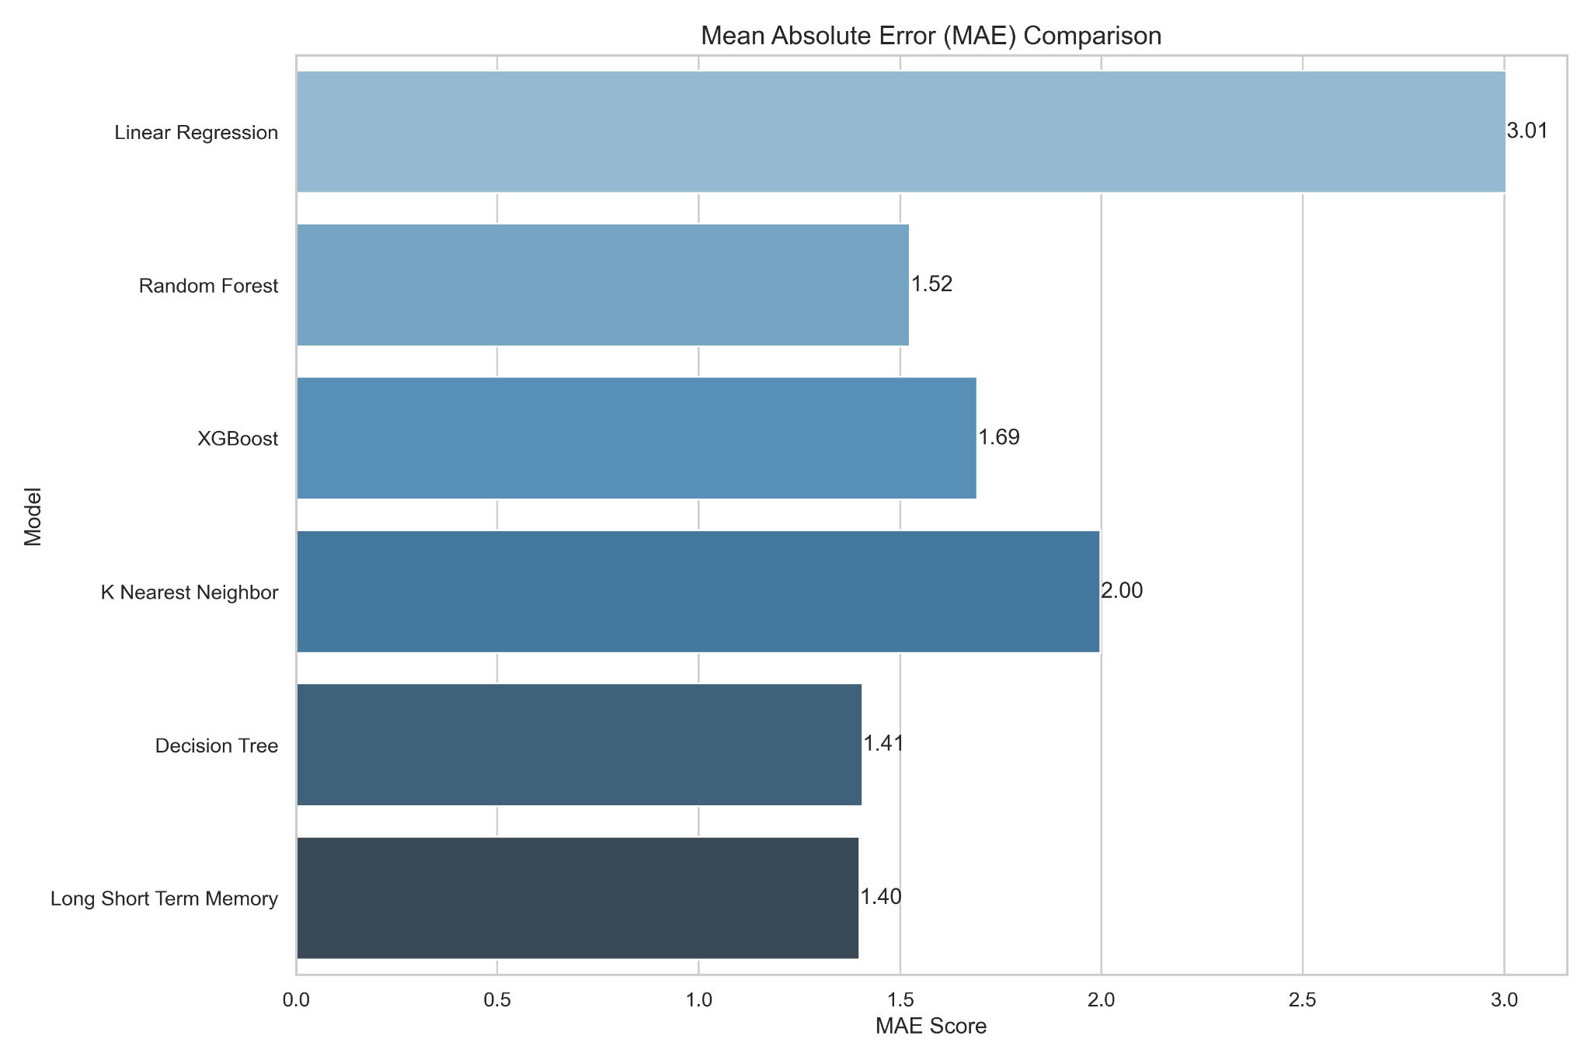

Figure 15. Mean Absolute Error Comparison

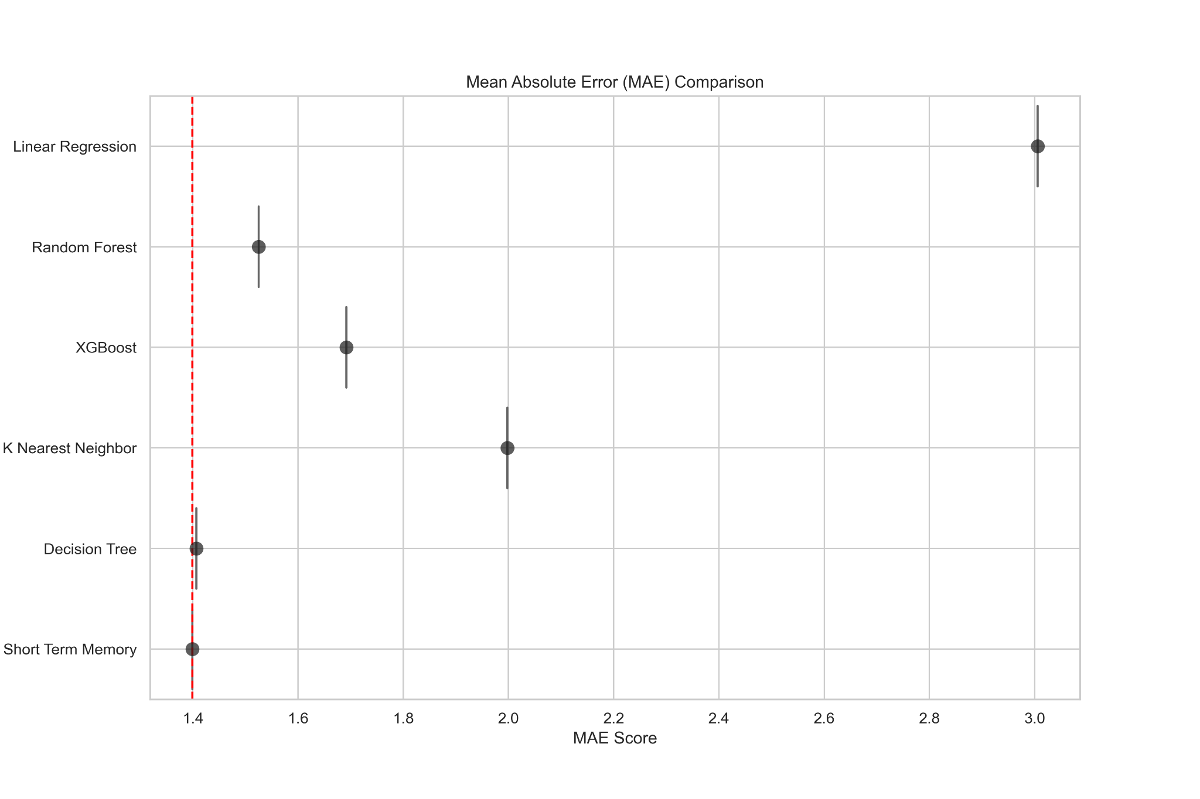

Figure 16. Optimal Mean Absolute Error Score

*Linear regression*

The Linear Regression model was trained to predict the finishing position of drivers based on training data shown. Each point within the below figure represents a specific data point and a diagonal line has been embedded to portray the prediction accuracy of this model. Ideally, the data points should cluster around this line to indicate a strong prediction accuracy. When looking at the plot, we can see a greater presence of data points below the diagonal line to indicate underpredictions in the model’s output.

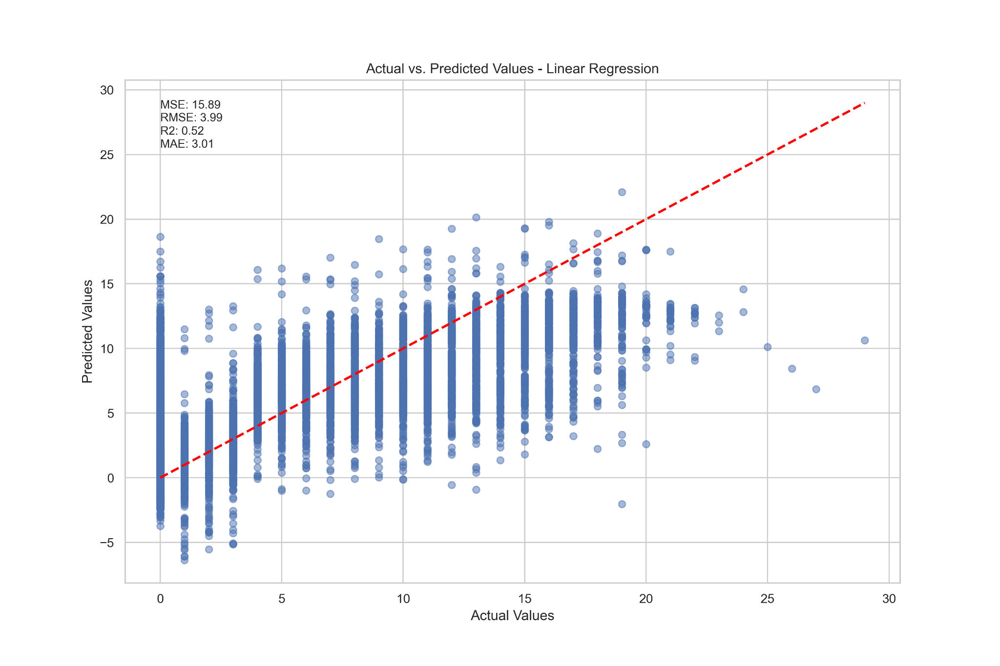

Figure 17. Actual vs. Predicted Values - Linear Regression

A greater display of underpredictions here indicates that the linear regression model has a bias towards lower values in the prediction outcomes. The dataset presented to the model exhibited non-linear relationships which can rationalize the conservative predictions. Looking at the relationship between a driver’s experience and weather conditions of a race, this relationship can be categorized as non-linear since some novice drivers can adapt to wet conditions better than others with greater race experience.

Figure 18. Residual Plots - Linear Regression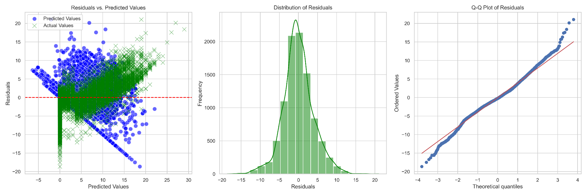

In the distribution of residuals plot, the visual test shows that there are more residuals closer to 0 and has a good level of symmetry. The quantile-quantile plot demonstrates deviations in the tails but the overall data fits well with the line and the residuals follow a normal distribution.

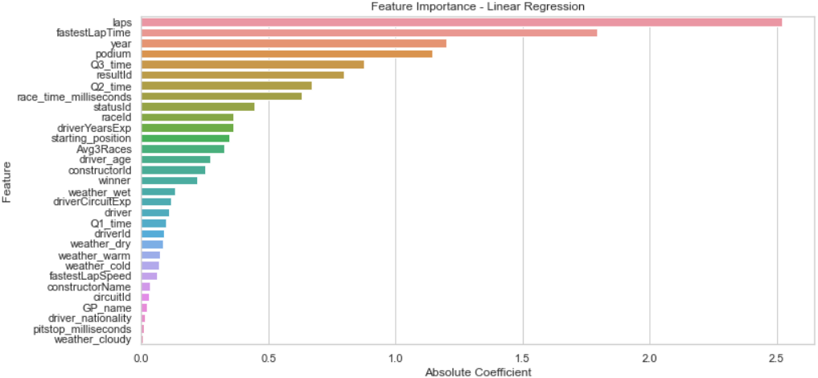

Figure 19. Feature Importance - Linear Regression

We can see from the above figure that the laps feature within the dataset had the greatest importance in the model’s prediction of the target variable, the finishing position. If a driver completes a relatively small number of laps in a race, this indicates that they experienced a performance issue during the race. Similarly, the marriage of this data with the fastestLapTime can give a clear indication of the best performing drivers in a race. Other features such as the qualification times and the year data featured highly in their importance for this test.

#### *Random Forest regression*

The Random Forest regression model shows a greater cluster of points along the diagonal line in comparison to the Linear Regression model. For Formula One race prediction, this represents an adaptability to non-linear features in the data (i.e. track conditions, weather conditions). The graph also highlights the reduced risk of underfitting and biased predictions when these patterns are captured by the ensemble of trees. However, the outliers within this graph can be the result of potential factors such as technical issues with the car performance or the introduction of a safety car which can affect a driver’s momentum and position.

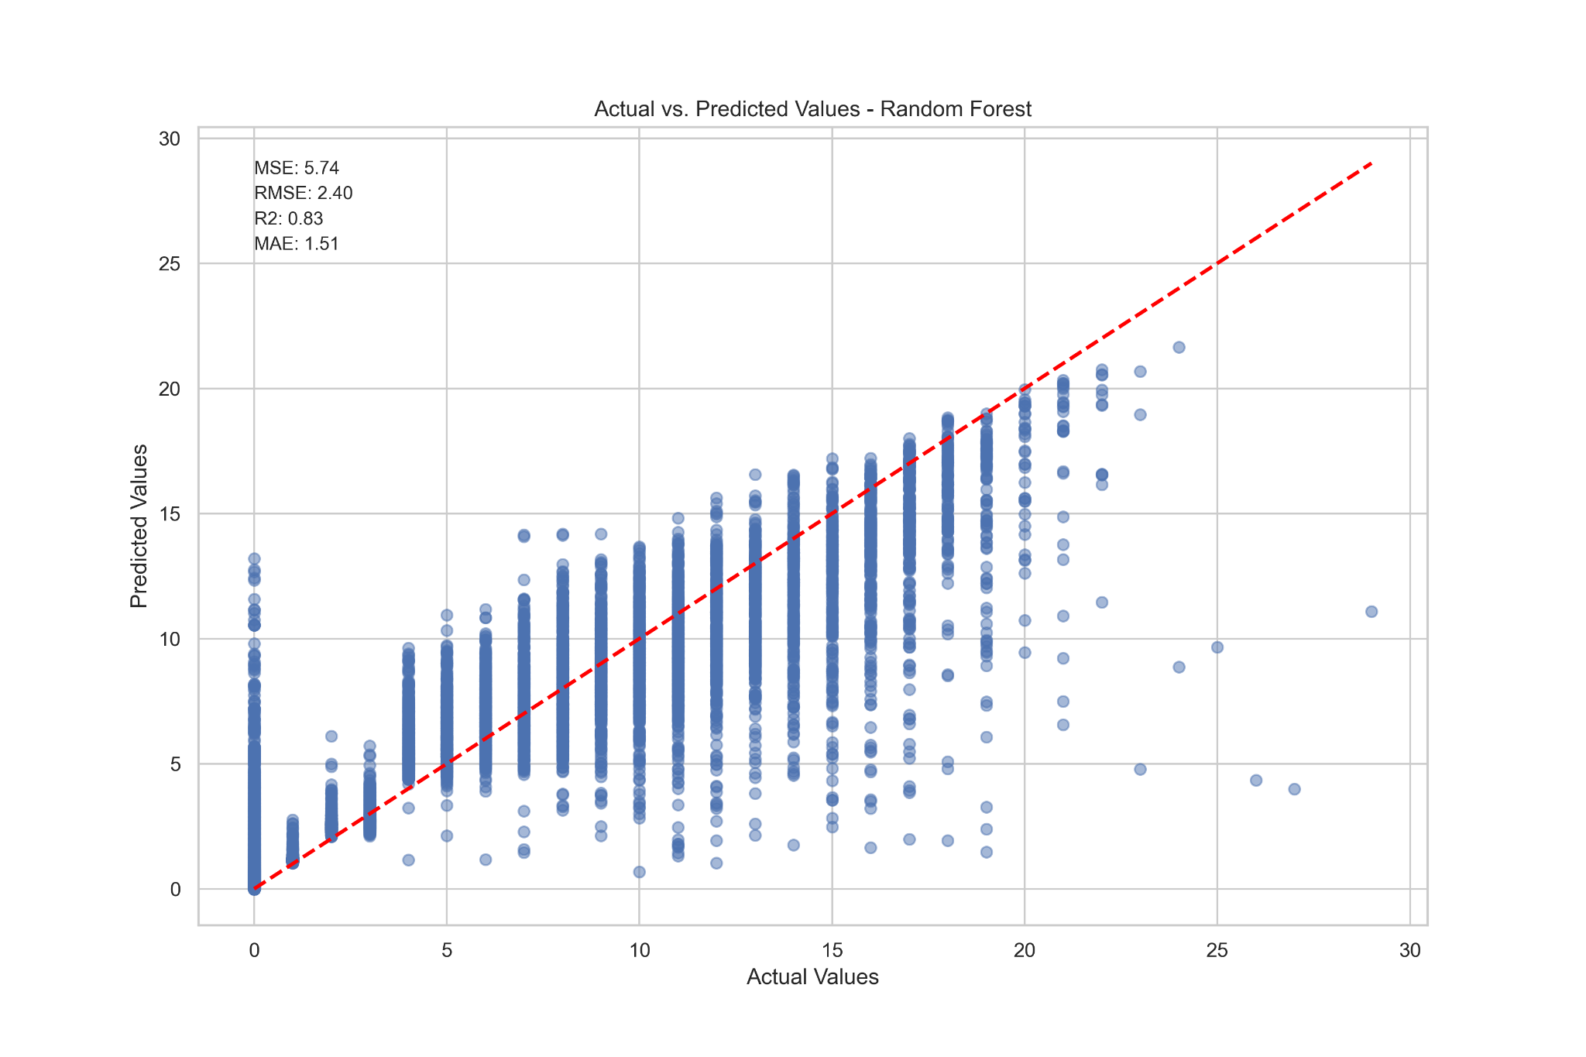

Figure 19. Actual vs Predicted Values - Random Forest

The distribution of residuals graph here shows a positive kurtosis (leptokurtic) which suggests the presence of outliers which is evident in the figure 19. The spread of residuals is greater in the residuals vs predicted values graph amongst the higher values and points to a variance across different scenarios of the model prediction. The quantile quantile plot demonstrates a greater deviation in comparison to the Linear regression model which also has to be noted here.

Figure 20. Residual Plots - Random Forest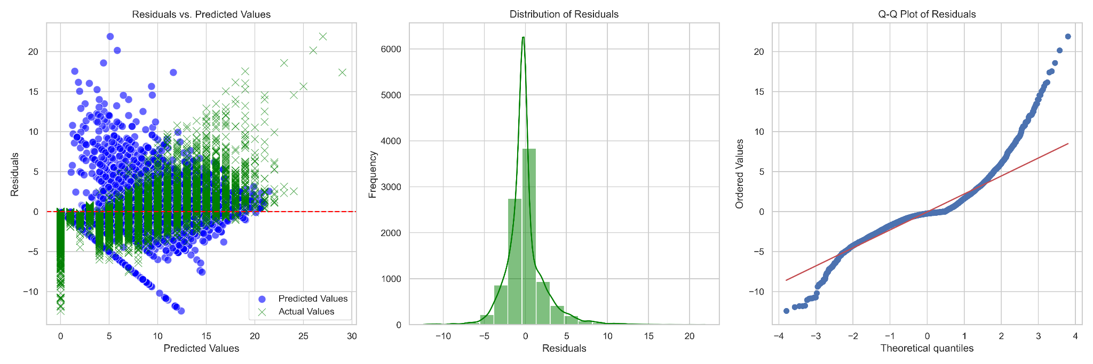

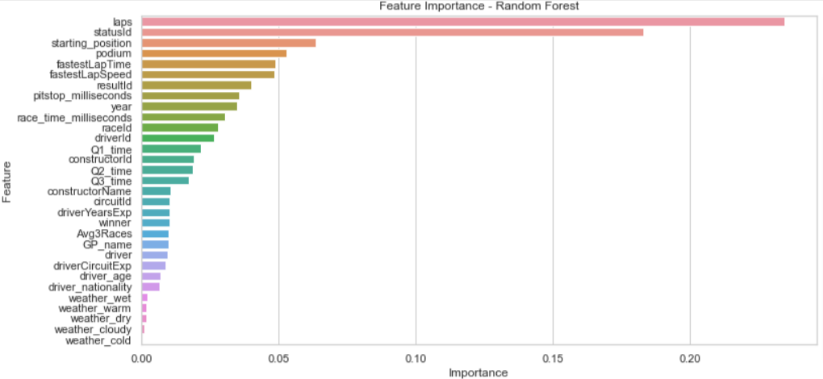

Figure 21. Feature Importance - Random Forest

#### 

To evaluate the feature importance of the Linear Regression model, we can see that the laps data ranked highest for the Random Forest model. The model placed higher importance on the statusId data, which confirms if a driver finished their race or experienced a collision or technical issue. This data feature can clearly distinguish the bottom half of the result standings and correctly classify their finishing position. The pit stop time data and fastest lap speed had a far superior importance score here compared to the Linear Regression model.

#### *XGBoost*

The XGBoost model performed similarly to the Random Forest model in most respects and the cluster of data points along the diagonal line here is akin to the Random Forest output. The dispersed points to the right of this graph demonstrate the inconsistency in the model’s predictions and random errors that were returned in the test. All three graphs so far have not shown a curved residual pattern in the graph which would suggest that the models have not captured the dynamics between the race data variables.

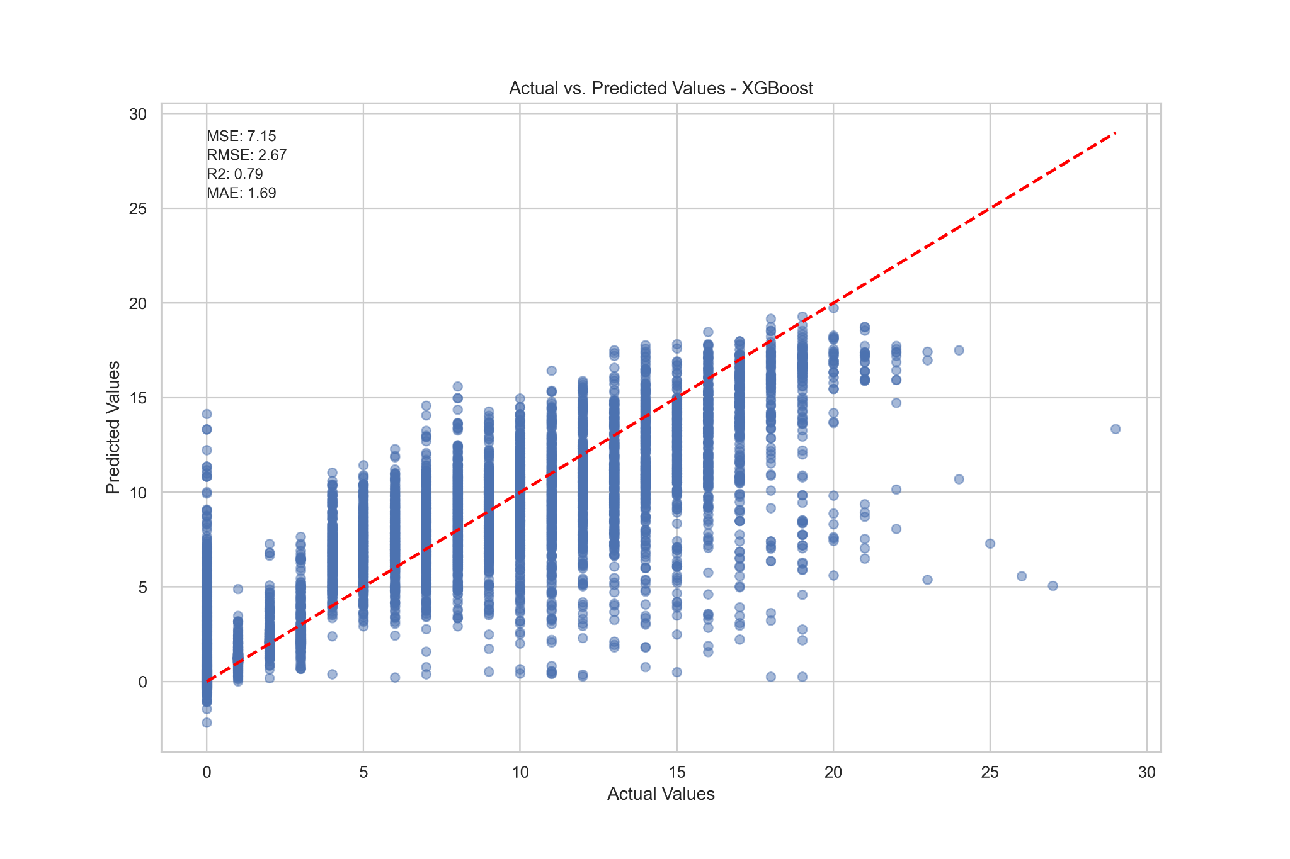

Figure 21. Actual vs. Predicted - XGBoost

The residuals vs. predicted values graph exhibits greater variance amongst the higher values to signify a similar error to that of the Random Forest model. The corresponding Linear Regression graph displayed a higher error rate in lower sections which can be seen in the mean squared error metric also. The distribution of residuals shows a strong tendency towards zero to imply a normal distribution and the quantile quantile plot illustrates a higher deviation from the line of best fit in the upper quartile.

Figure 22. Residual Plots - XGBoost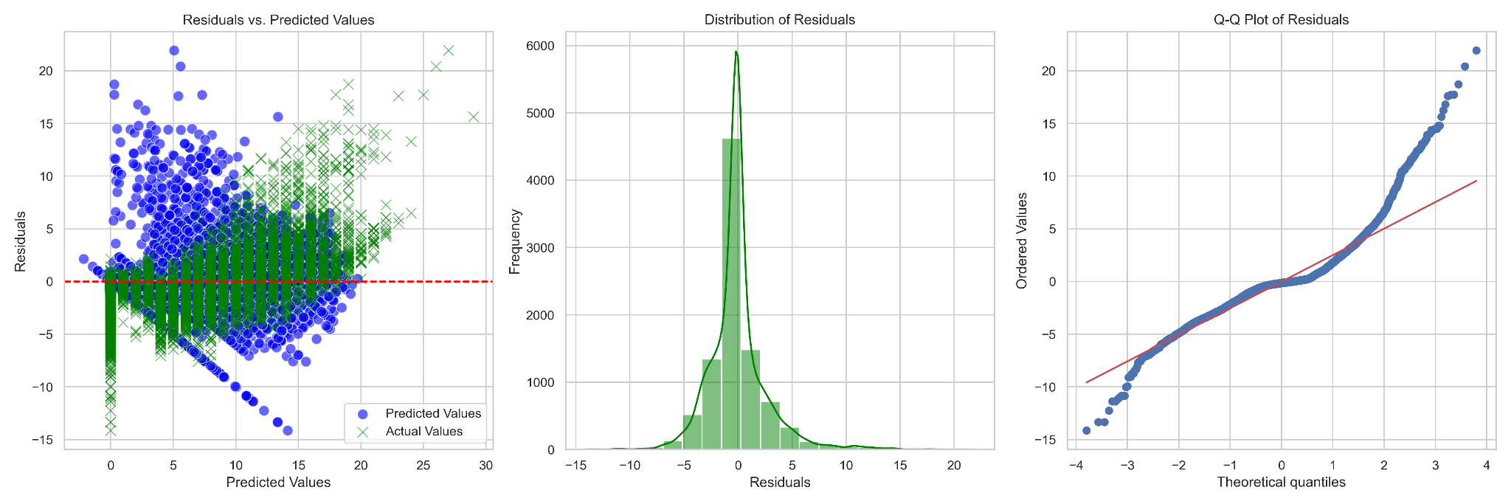

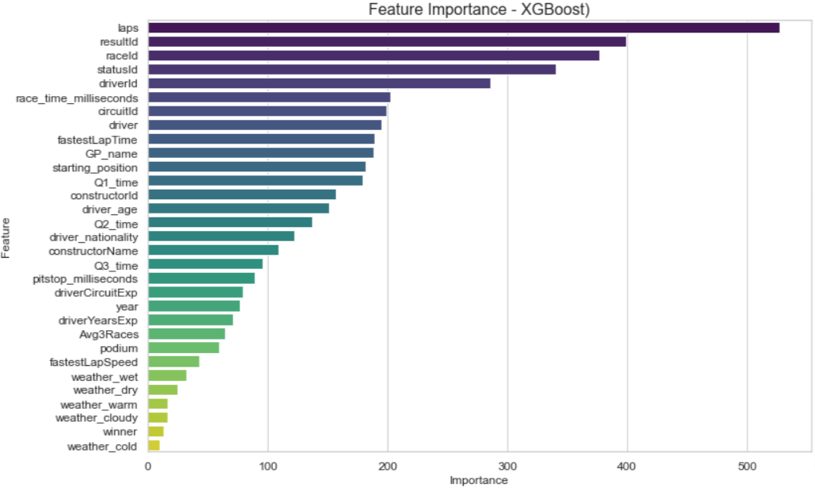

Figure 23. Feature Importance - XGBoost

A theme in the feature importance data has emerged as the laps data achieved the highest rank once again. This data feature clearly outweighs the other variables in the XGBoost predictive model. The resultId feature ranks second highest which places a strong emphasis on previous race results to determine the finishing position of each driver in a predictive model. This is closely followed by the raceId to identify the conditions of the race track and utilize previous data from past races on this track.

#### *K-Nearest Neighbors*

The K-Nearest Neighbors model demonstrates a similar dispersion of data points to the Linear Regression model here. A greater presence of underpredictions are shown which suggests areas for improvement within this KNN model. Hyperparameter tuning was optimized through GridSearch to ensure the best possible combinations were provided to the model. Given that Formula One is an ever-evolving sport, this model requires adjusted feature selection in order to be introduced into the professional decision making process.

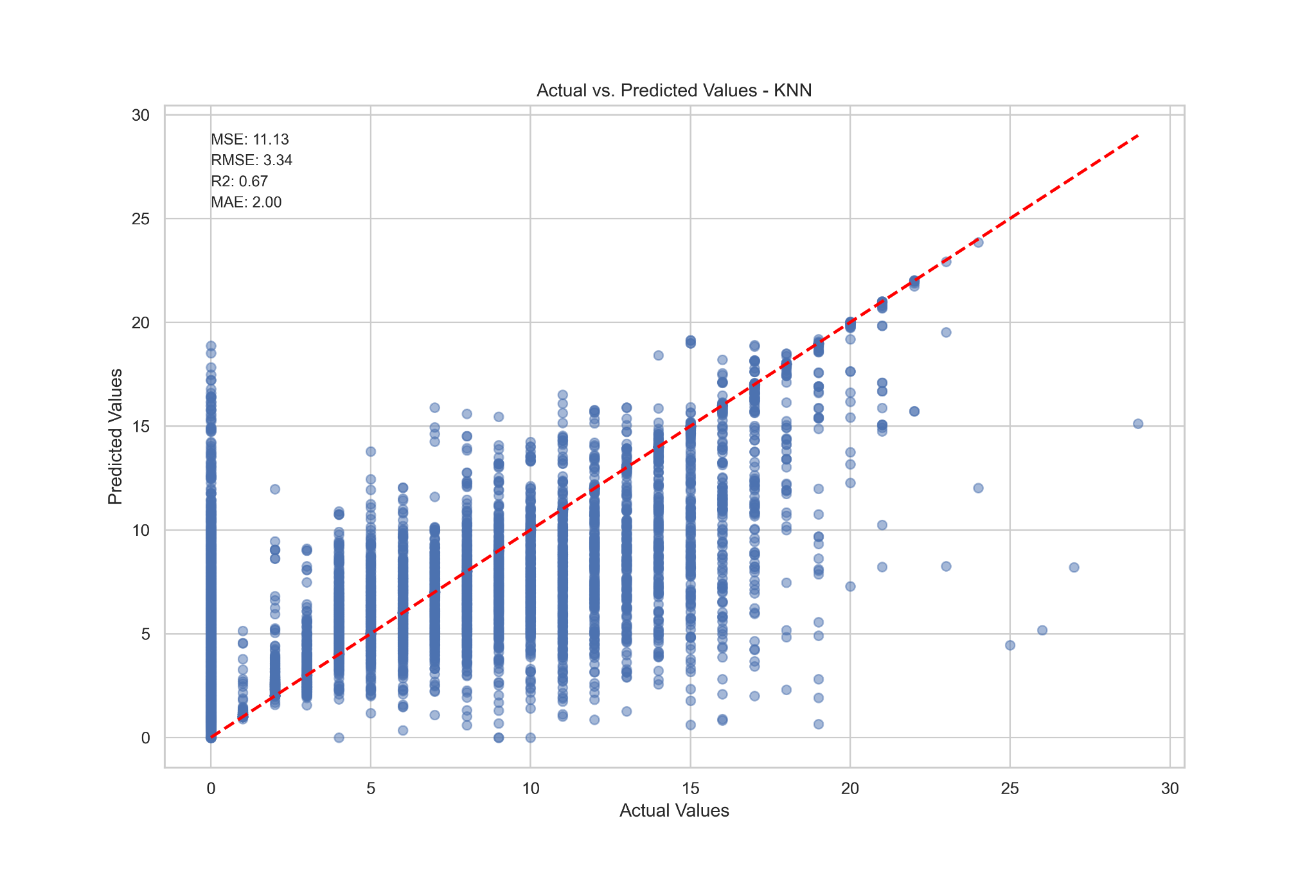

Figure 27. Actual vs. Predicted Values - KNN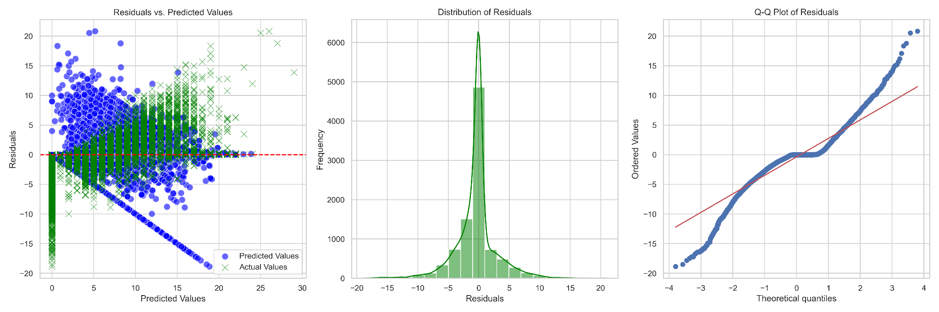

Figure 28. Residual Plots - KNN

In the distribution of residuals plot, the visual test shows that there are more residuals closer to 0. The quantile-quantile plot demonstrates deviations in the tails but the deviation is greater than most models. The bends away from the diagonal line here imply that the dataset has more extreme values and less power in predicting race outcomes. The Q-Q plot emphasises the distributional characteristics of data and shows that the model may not assume a normal distribution of predictor variables here.

#### *Decision Tree Regression*

The Decision Tree model returned a mean squared error score of 6.63 which was third best in this specific test. Decision Trees are inherently interpretable models and can benefit race strategists to understand decision points that can influence the race outcomes. However, they are also prone to overfitting and a scattered distribution of points in the below figure would highlight this in the model. A reduction of tree depth and complexity (pruning) would help to balance the model and improve the alignment further in this figure.

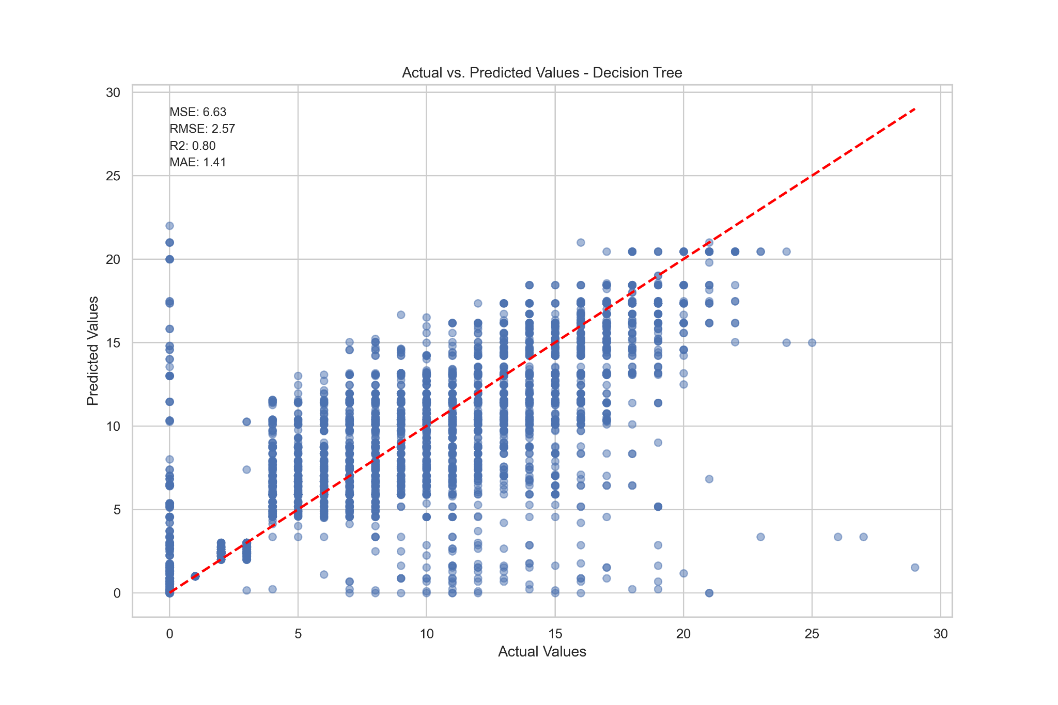

Figure 29. Actual vs. Predicted Values - Decision Tree

The residual plot below, like others, demonstrates heteroscedasticity, as a spread of predicted values varies across the graph. The model’s performance can be deemed somewhat inconsistent and widens when the values increase. The predictive accuracy can be reduced when this is present. The distribution of residuals show a tendency to zero and a deviation from the line in the quantile quantile plot as the values increase.

Figure 30. Residual Plots - Decision Tree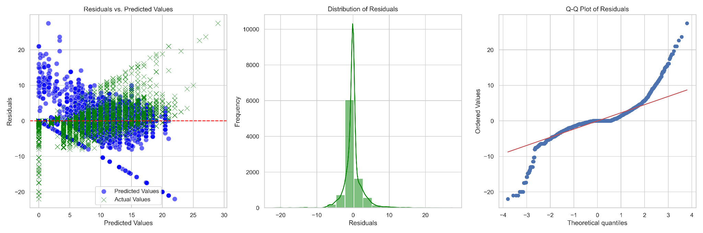

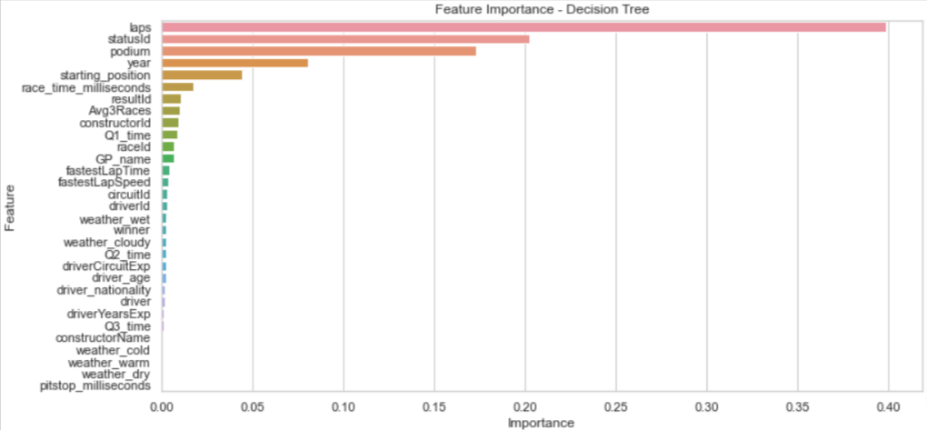

Figure 31. Feature Importance - Decision Tree

The lap data again achieved an importance score of almost double its closest rival in this feature importance test. The removal of the points data has to be noted here also due to its strong correlation with the finishing position target variable. It is expected that this data would be amongst the top ranking features if included. Other features such as the status of a driver’s finish in a race and top 3 finishes (podium) ranked as important for the model’s predictions.

#### *Long Short Term Memory*

The final machine learning model to be deployed and evaluated here is the Long Short Term Memory model. This neural network is particularly useful for sequential data and can capture time dependencies in Formula One data better than others. This can also lead to greater predictive accuracy once its hyperparameter tuning is optimized, as previously mentioned in the modelling phase. The figure below shows a trend to the accuracy line and a mean absolute error of 1.40 ranked best amongst all models deployed.

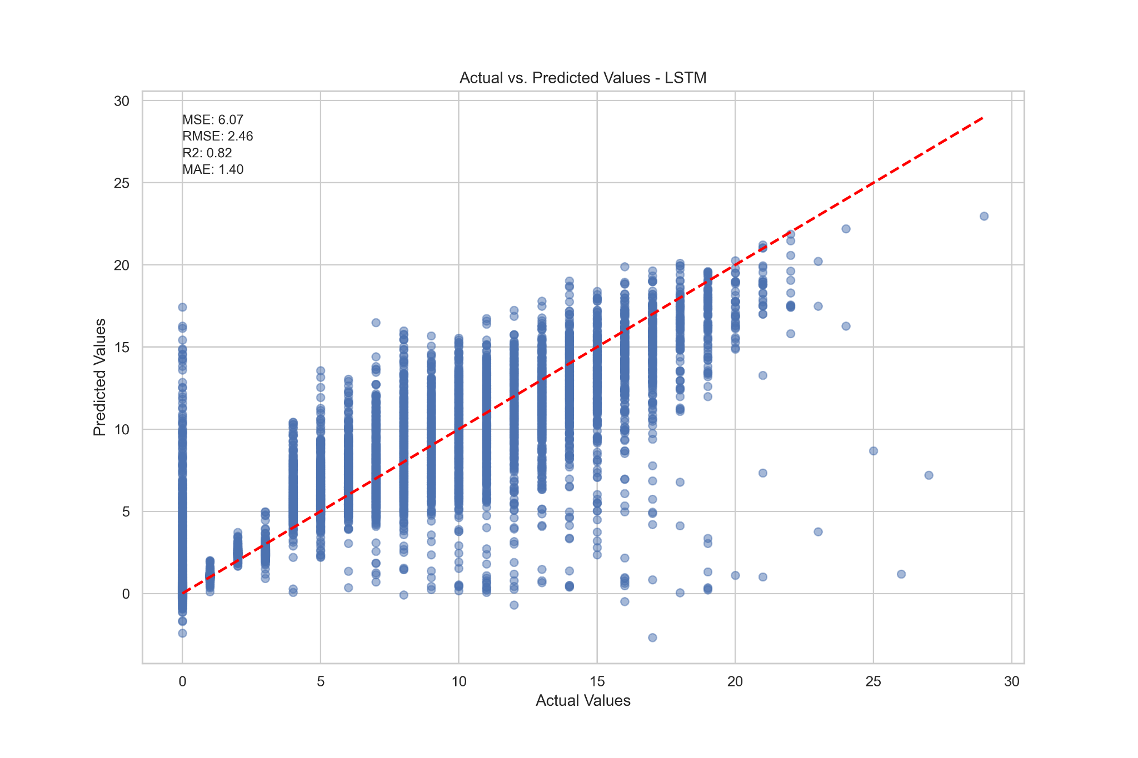

Figure 32. Actual vs. Predicted Values - LSTM

The residual plot demonstrates similar heteroscedasticity as the previous Decision Tree model. The LSTM model widens when the values increase here and shows greater variance in that respect. The distribution of residuals show a tendency to zero and a deviation from the line in the quantile quantile plot as the values increase is similar to the Decision Tree results but still follow the expected distribution better from visually inspecting the graph.

Figure 33. Actual vs. Predicted Values - LSTM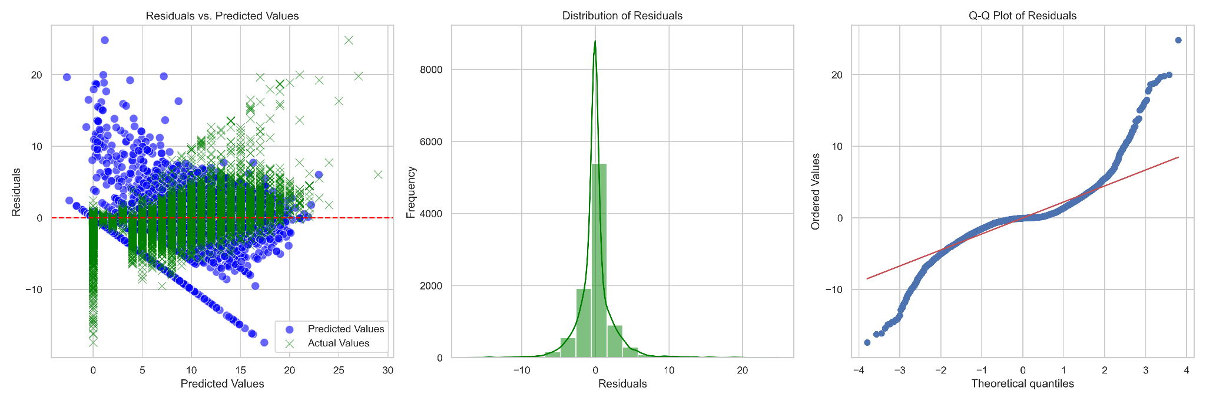

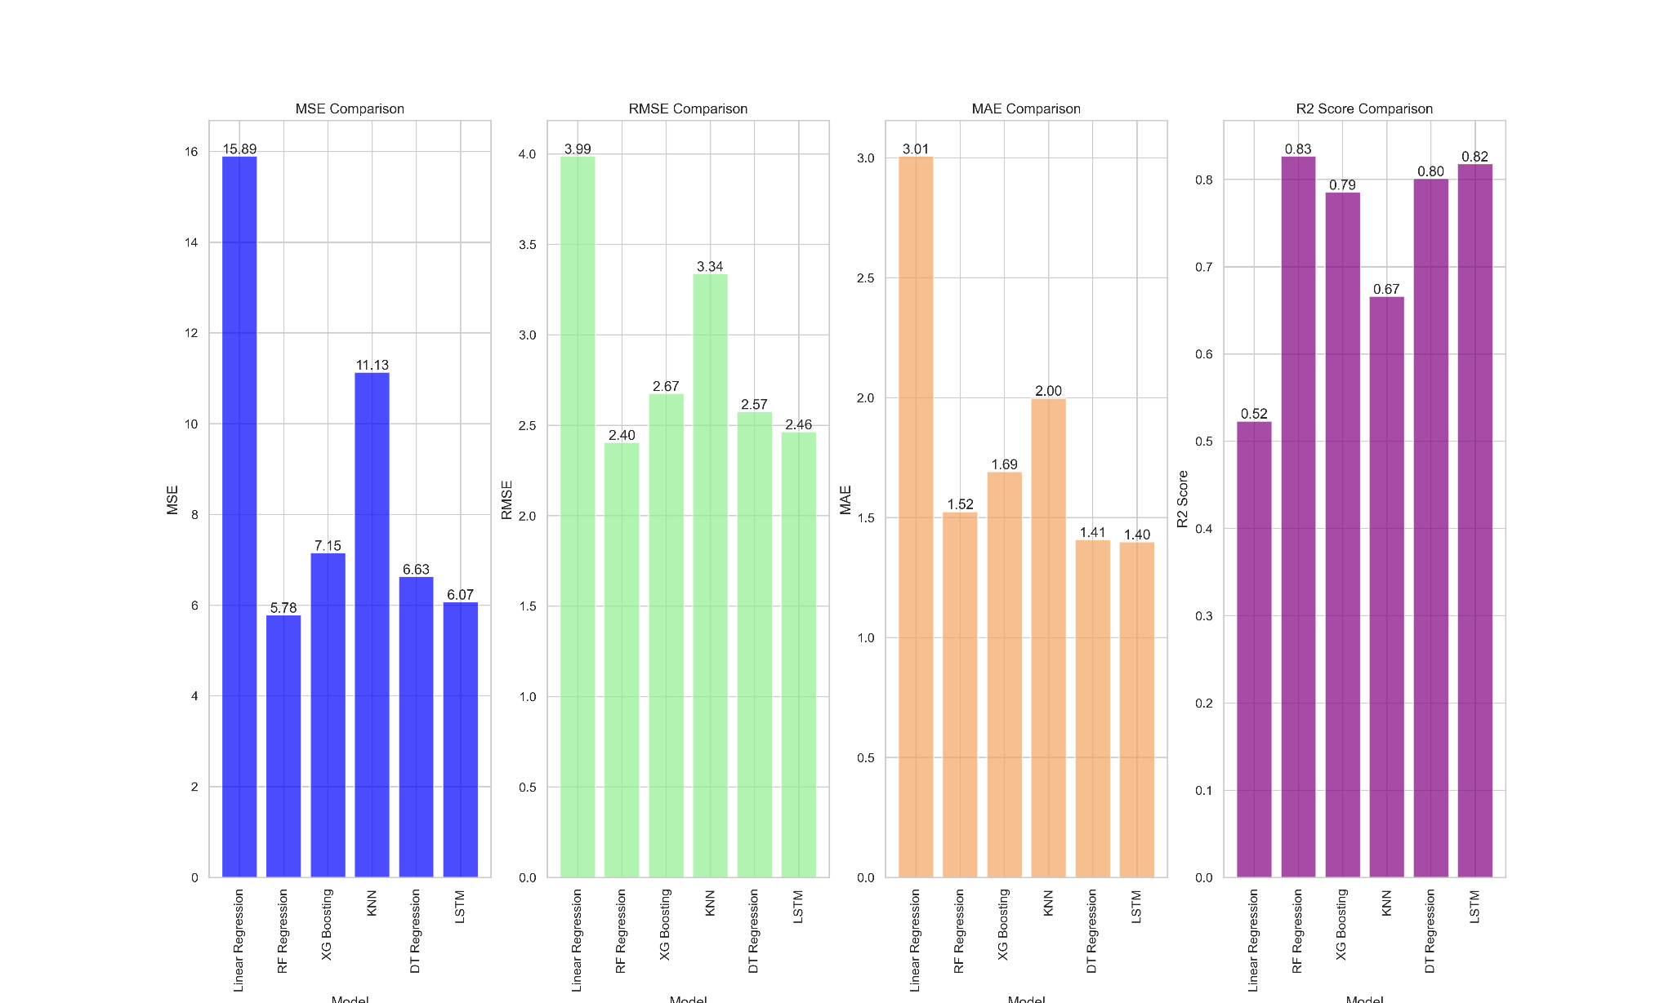

Figure 34. Model Comparison

### *Model Deployment*

### *Further Research*

Tyre change - this represents an important strategic decision by the team in any Formula One race. Although the speed of a Formula One car is more dependent on the car's capabilities and driver ability, the choice of tyre compounds at both the beginning of a race and during a race can yield significant advantage. The application of fresh tyres lead to greater performance and various factors such as weather, tyre degradation (wearing of tyre) and nearest rival’s pit strategy can influence the stage at which these changes are made in the pit stop during a race.

The Formula One regulations state that every driver must use at least two tyre compounds during a race unless wet weather plays a part in a race. This can result in a driver starting with soft tyre compounds to set faster lap times early in the race, before reverting to hard tyre compounds towards the end of a race and hoping to maintain their position against drivers which have reversed this strategy. The inclusion of tyre data such as the lap number where each driver entered the pit stop and which tyre compounds were used would offer greater predictive power to the models presented.

## References

[1] Saitta L, Neri F. Learning in the ‘‘real world’’. Machine Learning 1998; 30:133–163.

[2] J. Schmidhuber. Deep learning in neural networks: An overview (2015)

[3] Mohammad, Thabtah, McCluskey. An improved self-structuring neural network. (2016)

[4] Anil K.Jain, Jianchang Mao and K.M.Mohiuddin; Artificial Neural Networks: A Tutorial; Computer March 1996

[5] Rory P. Bunker, Fadi Thabtah, A machine learning framework for sport result prediction, Volume 15, Issue 1, (2019)

[6] P.J. Werbos. Applications of advances in nonlinear sensitivity analysis (2005)

[7] Qabajeh, Thabtah, Chiclana. A dynamic rule-induction method for classification in data mining. (2015)

[8] L. a. H. J. G. Passfield, "A Mine of Information: Can Sports Analytics Provide Wisdom From Your Data?," International Journal of Sports Physiology and Performance, vol. 12, no. 7, pp. 1-17, December 2016

[9] U. Johansson and C. Sonstrod; Neural Networks Mine for Gold at the Greyhound Track ; International Joint Conference on Neural Networks, Portland, OR. (2003)

[10] H. Chen et al.; Expert Prediction, Symbolic Learning, and Neural Networks: An Experiment on Greyhound Racing; 1994-12, 9(6):21-27 IEEE Expert

[11] Davoodi, E.; Khanteymoori, A.R. Horse racing prediction using artificial neural networks. In Proceedings of the 11th WSEAS International Conference on Neural Networks, Evolutionary Computing and Fuzzy Systems, Iasi, Romania, 13–15 June 2010; pp. 155–160

[12] F. Kamalov, F. Thabtah. A feature selection method based on ranked vector scores of features for classification (2017)

[13] Ofoghi, B., Zeleznikow, J., Macmahon, C., Rehula, J., & Dwyer, D. B. (2016). Performance analysis and prediction in triathlon. Journal of sports sciences, 34(7), 607–612

[14] K.Przednowek. J.Iskra and K.H.Przednowek; Predictive modeling in 400-metres hurdles races; Proceedings of the 2nd International Congress on Sports Sciences Research and Technology Support 2014, Pages 137-144

[15] S. Grossberg. Nonlinear neural networks: principles, mechanisms, and architectures (1988)

[16] Edelmann-Nusser, J.; Hohmann, A.; Henneberg, B. Modeling and prediction of competitive performance in swimming upon neural networks. Eur. J. Sport Sci. 2002, 2, 1–10

[17] M. A. Sartori and P. J. Antsaklis; A simple method to derive bounds on the size and to train multilayer neural networks; IEEE Transactions on Neural Networks, Vol. 2, pp. 467–471, 1991

[18] Pratt, J. Risk Aversion in the Small and in the Large. Econometrica 1964, 32(1-2), 122-136

[19] Langley P, Simon HA. Applications of machine learning and rule induction. Commun. ACM 1995; 38:54–64

[20] Abut, F., Akay, M. F., Daneshvar, S., & Heil, D. (2017, September). Artificial neural networks for predicting the racing time of cross-country skiers from survey-based data. In 2017 9th International Conference on Computational Intelligence and Communication Networks (CICN) (pp. 117-121)

[21] Daniel Svozil, Vladimír Kvasnicka, Jir̂í Pospichal,Introduction to multi-layer feed-forward neural networks,Chemometrics and Intelligent Laboratory Systems, Volume 39, Issue 1, 1997 (Pages 43-62)

[22] Du, Ke-Lin & Swamy, M.N.s. (2014). Radial Basis Function Networks

[23] Sankaranarayanan VV, Sattar J, and Lakshmanan LVS. Auto-play: A data mining approach to ODI cricket simulation and prediction. In: Proceedings of the 2014 SIAM International Conference on Data Mining, 1064– 1072. SIAM 2014

[24] Acuna, E., & Rodriguez, C. (2004). The treatment of missing values and its effect on classifier accuracy. In Classification, clustering, and data mining applications (pp. 639-647). Springer, Berlin, Heidelberg

[25] Bailey M, and Clarke SR. Predicting the match outcome in one day international cricket matches, while the game is in progress. Journal of Sports Science & Medicine 2006; 5:480

[26] Marcano-Cedeno, Quintanilla-Dominguez, Cortina-Januchs, Andina. Feature selection using Sequential Forward Selection and classification applying Artificial Metaplasticity Neural Network. (2010)

[27] N. Tax and Y. Joustra; Predicting The Dutch Football Competition Using Public Data: A Machine Learning Approach; Transactions on knowledge and data engineering, Vol. 10, No. 10, pp. 1-13, 2005

[28] Joseph, A.; Fenton, N.; Neil, M. Predicting football results using Bayesian nets and other machine learning techniques. Knowl.-Based Syst. 2006, 19, 544–553

[29] Fayyad U, Piatetsky-Shapiro G, and Smyth P. From data mining to knowledge discovery in databases. AI Magazine 1996; 17:37–54

[30] J. Goddard, "Regression models for forecasting goals and match results in association football," International Journal of Forecasting, vol. 21, no. 2, pp. 331-340, 2005

[31] J. a. R. A. Hucaljuk, "Predicting football scores using machine learning techniques," in MIPRO, 2011 Proceedings of the 34th International Convention, Opatija, Croatia, 2011

[32] Z. Y. Broich, "Statistical Analysis for the First Bundesliga in the Current Soccer Season," Progress in Applied Mathematics, vol. 7, no. 2, pp. 1-8, 2014

[33] Bergstra, J., & Bengio, Y. (2012). Random search for hyper-parameter optimization. Journal of machine learning research, 13(Feb), 281-305

[34] S. Kampakis, "Using Twitter to predict football outcomes," 2014

[35] S. Kampakis, "Predictive modelling of football injuries," arXiv:1609.07480, London, UK, 2016

[36] S. O. Rue, "Predicting and Retrospective Analysis of Soccer Matches in a League," Department of Mathematical Science, NTNU, Norway, 2000

[37] R. M. Crowder, "Dynamic Modelling and Prediction of English Football League Matches for Betting," Journal of the Royal Statistical Society, vol. 51, no. 2, pp. 157-168, 2002

[38] S. Raychaudhuri, "Introduction to Monte Carlo simulation," 2008 Winter Simulation Conference, Miami, FL, USA, 2008, pp. 91-100

[39] Ulmer, B., Fernandez, M., & Peterson, M. (2013). Predicting soccer match results in the XI English Premier League (Doctoral dissertation, Ph. D. thesis, Doctoral dissertation, Ph. D. dissertation, Stanford)

[40] Friedman, J. H. (2002). Stochastic gradient boosting. Computational statistics & data analysis, 38(4), 367-378

[41] Probst, P., Wright, M. N., & Boulesteix, A. L. (2019). Hyperparameters and tuning strategies IX for random forest. Wiley Interdisciplinary Reviews: Data Mining and Knowledge Discovery, 9(3), e1301

[42] McCabe, A.; Trevathan, J. Artificial Intelligence in Sports Prediction. In Proceedings of the Fifth International Conference on Information Technology: New Generations (itng 2008), Las Vegas, NV, USA, 7–9 April 2008.

[43] M.A. Hall. Correlation-based Feature Subset Selection for Machine Learning (1999)

[44] Haghighat, M.; Rastegari, H.; Nourafza, N. A Review of Data Mining Techniques for Result Prediction in Sports. ACSIJ Adv. Comput. Sci. Int. J. 2013, 2, 7–12

[45] Platt, J. C., (1999). Fast Training of Support Vector Machines using Sequential Minimal Optimization. Advances in Kernel Methods: Support Vector Learning. B. Scholkopf, C. Burges and A. Smola. Cambridge, MA, MIT Press: 185-208

[46] J. Jane, E. N. Ganesh. A Review On Big Data With Machine Learning and Fuzzy Logic For Better Decision Making (2019)

[47] P. Melin, O. Casstillo. Hybrid Intelligent Systems for Pattern Recognition Using Soft Computing: An Evolutionary Approach for Neural Networks and Fuzzy Systems

[48] M.C. Purucker; Neural network quarterbacking; IEEE Potentials, 15(1996), pp. 9-15

[49] J. Kahn; Neural network prediction of NFL football games; World Wide Web Electronic Publication, 2003 (2003), pp. 9-15

[50] C.K. Leung and K.W. Joseph; Sports data mining: predicting results for the college football games; Procedia Computer Science 35, pp. 710-719, 2014

[51] Delen, D.; Cogdell, D.; Kasap, N. A comparative analysis of data mining methods in predicting NCAA bowl outcomes. Int. J. Forecast. 2012, 28, 543–552

[52] S. Talukder, "Preventing in-game injuries for NBA players," in MIT Sloan Sports Analytics Conference 2016, Boston, MA, USA, 2016.

[53] J. Kuehn, "Accounting for Complementary Skill Sets When Evaluating NBA Players’ Values to a Specific Team," in MIT Sloan Sports Analytics Conference 2016, Boston, MA, USA, 2016.

[54] Wiseman, Using Machine Learning to Predict the Winning Score of Professional Golf Events on the PGA Tour (2016).

[55] Witten, I. H. & Eibe, F. Data Mining: Practical Machine Learning Tools and Techniques. San Francisco:2005, Morgan Kaufmann.

[56] Pfitzner CB, Rishel TD. Do reliable predictors exist for the outcomes of races? The Sport Journal, March 4, 2008.

[57] M. Allender; Predicting The Outcome Of NASCAR Races: The Role Of Driver Experience; Journal of Business & Economics Research, Vol. 6, No. 3, pp. 79-84, March 2008

[58] C. Depken and L. Mackey; Driver success in the Sprint Cup series: The impact of multi-car teams; Social Science Research Network. Available online at: <http://ssrn.com/abstract=1442015> 2017

[59] Mercedes-AMG Petronas Formula One - YouTube. How Much Data Does an F1 Car Generate? 2022

[60] A. Woodie. Go Fast and Win: The Big Data Analytics of F1 Racing (2018)

[61] Bell, A., Smith, J., Sabel, C. E., & Jones, K. (2016). Formula for success: multilevel modelling of Formula One driver and constructor performance, 1950–2014. Journal of Quantitative Analysis in Sports, 12(2), 99-112.

[62] Eichenberger, R., & Stadelmann, D. (2009). Who Is The Best Formula 1 Driver? An Economic Approach to Evaluating Talent. Economic Analysis & Policy, 39(3)

[63] Silva, K. M., & Silva, F. J. (2010). A tale of two motorsports: A graphical-statistical analysis of how practice, qualifying, and past success relate to finish position in NASCAR and Formula One racing.

[64] Graves, T., Reese, C. S., & Fitzgerald, M. (2003). Hierarchical models for permutations: Analysis of auto racing results. Journal of the American Statistical Association, 98(462), 282-291.

[65] Biemann, Liu, Zeng and Huang. Addressing partial observability in reinforcement learning for energy management (2021)

[66] Choo, C.L.W. Real-Time Decision Making in Motorsports: Analytics for Improving Professional Car Race Strategy. Master’s Thesis, Massachusetts Institute of Technology, Cambridge, MA, USA, 2015.

[67] Tulabandhula, T.; Rudin, C. Tire Changes, Fresh Air, and Yellow Flags: Challenges in Predictive Analytics for Professional Racing. Big Data 2014, 2, 97–112.

[68] Aversa, P.; Cabantous, L.; Haefliger, S. When decision support systems fail: Insights for strategic information systems from Formula 1. J. Strateg. Inf. Syst. 2018, 27, 221–236.

[69] Jenkins, M. (2010). Technological discontinuities and competitive advantage: A historical perspective on Formula 1 motor racing 1950–2006. Journal of Management Studies, 47(5), 884-910

[70] Aversa, P., Furnari, S., & Haefliger, S. (2015). Business model configurations and performance: A qualitative comparative analysis in Formula One racing, 2005–2013. Industrial and Corporate Change, 24(3), 655-676

[71] Rosso, G., & Rosso, A. F. (2016). Statistical Analysis of F1 Monaco Grand Prix 2016. Relations Between Weather, Tyre Type and Race Stints.

[72] Koenker, Roger, and Kevin F. Hallock. 2001. "Quantile Regression." Journal of Economic Perspectives, 15 (4): 143-156

[73] A. Sundar, "Here is everything you want to know about sports analytics," 24 August 2018. [Online]. Available: <https://dataconomy.com/2018/08/here-is-everything-you-wantto-know-about-sports-analytics>

[74] Amazon Web Services, Inc. F1 Insights Powered by AWS. Available online: <https://aws.amazon.com/de/f1> 2020

[75] Frank, Trigg, Holmes, Witten. (1999). “Naive Bayes for Regression” University of Waikato; 9-18